

MEK6802D5

MICROCOMPUTER
EVALUATION BOARD
USER’S MANUAL

PREFACE

The MEK6802D5 Microcomputer Evaluation Board provides the necessary hardware and firmware for a computer system based on the Motorola MC6802 Microprocessor. The system forms an evaluation tool to facilitate the application of Motorola microprocessors and associated components. The system is supplied with all the components required to operate, including a 115 Vac plug-in transformer and integral power supply and can be used in various configurations. With the in-formation supplied in this manual, the user can prototype dedicated systems plus write and evaluate software programs in machine language. Provisions are made for extensive system expansion using a video terminal or keyboard and
CRT/TV display unit.

The information in this document has been carefully checked and is believed to be entirely reliable. However, no responsibility is assumed for inaccuracies. Furthermore, such information does not convey to the purchaser of this product any license under the patent rights of Motorola, Inc., or others.

Second Edition
© Motorola, Inc., 1980
All Rights Reserved
Printed in USA

Table of Contents
MEK6802D5 SPECIFICATIONS 4
Chapter 1 General Information 5
1.1 Description 5
1.2 Components 5
1.2.1 MC6802 - MPU (U5) 5
1.1.1 MC68A316E - D5BUG (U12) 5
1.1.2 MC6821 - PIA (U23) 5
1.1.3 MC6821 - PIA (U9) 6
1.1.4 MC6810 - Static RAM (U11) 6
1.1.5 LED Display 6
1.1.6 Keyboard 6
1.3 Optional Devices 6
1.1.7 MC2114 RAM Memories (U7, U8) 6
1.1.8 Bus Drivers (U1, U2, U3, U10) 6
Chapter 2 CHAPTER INSTALLATION 7
2.1 Preparation For Use 7
1.1.9 Handling 7
2.2 Use 7
2.3 Precautions 7
1.1.10 Handling of Unmounted Chips 8
2.4 Pin Assignments 8
2.5 System Bus Signal Description 8
2.6 System Interfaces 10
1.1.11 Power 10
1.1.12 7.2.13 PNCHB (cont’d) 62
1.1.13 7.2.14 PUNCH ($F630) 62
1.1.14 7.2.14 PUNCH (cont’d) 63
1.1.15 7.2.15 LOAD ($F69C) 63
1.1.16 7.3 Program Address Descriptions 65
1.1.17 Table 7.2 — Summary of most used D5BUG scratch RAM locations 66
1.1.18 Table 7.3 — Useful hardware address information 67
1.1.19 Table 7.3 (cont’d) — Useful hardware address information 68
1.1.20 7.6 D5BUG Listing 68

MEK6802D5 SPECIFICATIONS

System Components: MC6802 Microprocessor
D5BUG Firmware (2K)
Six 7-segment displays
25-key scanned keypad
300 Baud cassette interface
Uncommitted user PIA
Wire Wrap area
On-board power supply

Supply Voltage: 120 Vac 60 Hz to external transformer, 18 Vac input to board, +5 Vdc regulated output on board.

Operating Temperature: 0 °C to 55 °C (32 °F to 131 °F)

Relative Humidity: To 80% without condensation
Dimensions: A two-sided printed circuit board measuring 9.75 in (247.65 mm) wide by 8.75 in (222.25 mm) high by 0.062 in (1.57 mm) thick.
Options/Expansion: Two (2) MCM2114 1K x 4 RAMs
One (1) ROM
Bus buffers
MEK6800AB Motherboard
MEK68R2 CRT display board
ASCII Keyboard
CRT/TV Monitor
MEK68MM RAM board
MEK68RR RAM/ROM board
MEK68IO Input/Output Interface
MEK68EP EPROM Programmer
Software Features: Memory Change/Display
Advance to next ADDR
Back-up to previous ADDR
Calculate offsets
Register Change/Display
Breakpoint Editor
Cassette punch/load/verify
Trace single instruction
Go To/Continue user program
User function capability
Escape from all functions
Save user registers

General Information

Description

The MEK6802D5 Microcomputer Evaluation Board is a basic, low-cost system to evaluate the capability of the MC6800 Microcomputer Family of Components. It is useful as a tool to learn programming technique, and to develop custom applications of microprocessors.
The system consists of an MC6802 microprocessor, D5BUG firmware in an
MC68A316E ROM, (6) 7-segment multiplexed displays, a 25-key scanned key-
pad, 300 Baud K.C. standard cassette interface and an on-board power
supply capable of driving the minimum system.
A wire wrap area and an uncommitted user PIA are provided to allow the
user to create desired options. In addition, provisions are made to add
(2) MCM2114 1K x 4 RAMs, a 24-pin ROM or EPROM, and Bus buffers to an
86-pin connector.
All components, including the AC transformer required for the minimum
system are supplied with the MEK6802D5.
The functions of the basic and optional components of the system are de-
scribed in the following sections.

Components

MC6802 - MPU (U5)
The microprocessor generates the system clock, executes the programs re-
siding in D5BUG, and also executes user programs. There are 128 bytes of
RAM (reserved for the user in the D5) included in the MC6802 (addresses
$0000 to $007F).

MC68A316E - D5BUG (U12)
This factory programmed ROM (Read Only Memory), also known as Monitor,
contains the operating system firmware programs which control the D5
system.

MC6821 - PIA (U23)
This PIA (Peripheral Interface Adapter) is the system PIA and interfaces
the keypad and display to the MPU. This unit can transmit data (in

parallel form) in either direction and provides a flow path for data in
or out of the system. It also interfaces the cassette interface cir-
cuitry and trace-one instruction timer to the MPU (U5).

MC6821 - PIA (U9)
This PIA interfaces the D5 to external devices or systems for the user
to use in producing custom designs. It provides two 8-bit bi-direc-
tional data ports and four control lines connected to a 24-pin Dip
socket located adjacent to U9.

MC6810 - Static RAM (U11)
This is a static RAM (Random Access Memory) used as a scratch pad for
the MPU (U5). It provides 128 bytes of Flag, Data, and Stack area for
the D5BUG operating system (24 bytes are allowed for use as user's
stack area).

LED Display
The display system consists of LEDs, U15, U16, U17, U18, U20, U21; anode
drivers Q1 through Q7; and cathode drivers U24 through U26. The system
PIA (U23) uses seven lines to drive the anode drivers and six lines to
drive the cathode drivers.

Keyboard
Depressing a key generates an interrupt to the processor. The system
firmware causes the processor to search for the key closure and act upon
it.

Optional Devices

MC2114 RAM Memories (U7, U8)
There are two 18 pin sockets for installing MCM2114 (1K x 4 bit) static
RAM memories.

Bus Drivers (U1, U2, U3, U10)
These units interface the processor to an 86 pin connector to expand the
MEK6802D5 system.

CHAPTER
INSTALLATION

Preparation For Use

Handling

CAUTION
Turn power off before removing or installing components

SPECIAL HANDLING REQUIRED
Store board in special conductive bag. Do not touch
circuitry while handling. Static discharge may damage
components.

Generally, it is required that the board and repairing personnel all
be at the same (ground) potential. If the unit is on a bench or is
not installed, a common ground connection between installing and/or
repairing personnel and the unit should be made.

Use
Place the D5 board on its stand offs or otherwise insulated from a
bench or table top and plug the transformer into a wall outlet of
the correct AC voltage. Refer to the operation section of this
manual for more information.

Precautions
Because MOS devices have extremely high input resistance, they are
susceptible to damage when exposed to high static electrical charges.
To avoid possible damage to the devices during handling, testing, or
actual operation, use the following procedures:
a) The leads of devices should be in contact with a conductive material,
except when being tested or in actual operation, to avoid build-up
of static charge.

Precautions (cont’d)
b) Soldering-iron tips, metal parts of fixtures and tools, and hand-
ling facilities should be grounded.
c) Devices should not be inserted into or removed from circuits
with the power on because transient voltages may cause permanent
damage.
d) Signals should not be applied to the inputs while the device
power supply is off.
e) All unused input leads must be connected to either VSS (ground)
or VDD (device supply), whichever is appropriate for the logic cir-
cuit involved.

Handling of Unmounted Chips
In handling of unmounted chips, care should be taken to avoid dif-
ferences in voltage potential. A conductive carrier, or a carrier
having a conductive overlay should be used.
Some CMOS chips use a double diode plus resistor input protection
circuit. This input protection circuit will clamp the input voltage
to the chip to within the VDD and VSS supply voltages. This will
protect the CMOS chip from over-voltages of 100 volts for 0.1 milli-
second. The static charges encountered in normal handling may be-
as high as 10,000 volts.

Pin Assignments
Refer to Table 2.1 for the Bus Pinout Assignments for the MEK6802D5.

System Bus Signal Description
System Bus Signals:
(1) 16 Address lines (A0-A15) - For selection of one byte or location
from 64K bytes or locations.
(2) 8 Data lines (D0-D7) - Bidirectional lines that carry data information.
(3) 9 Control lines:
(a) E - ENABLE. This signal is the system clock. A standard
3.579545 MHz crystal is used by the processor to generate
the 894.8 KHz system clock.
2-2

Pin | Description | Pin | Description
1 | +5 VDC | A | +5 VDC
2 | +5 VDC | B | +5 VDC
3 | +5 VDC | C | +5 VDC
4 | HALT | D | IRQ
5 | RESET | E | NMI
6 | R/W | F | VMA
7 |  | H
8 | +12 V GND (ref) | J | E (Ø2)
9 | +12 V GND (ref) | K | +12 V GND (ref)
10 |  | L
11 | -12 V (ref) | M | -12 V (ref)
12 |  | N
13 |  | P | BA
14 |  | R | MR
15 |  | S
16 | +12 V (ref) | T | +12 V (ref)
17 |  | U
18 |  | V
19 |  | W
20 |  | X
21 |  | Y
22 |  | Z
23 |  | A̅
24 |  | B̅
25 | -5 V (ref) | C̅
26 |  | D̅
27 |  | E̅
28 |  | F̅
29 | D1 | H̅ | D3
30 | D5 | J̅ | D7
31 | D0 | K̅ | D2
32 | D4 | L̅ | D6
33 | A15 | M̅ | A14
34 | A12 | N̅ | A13
35 | A11 | P̅ | A10
36 | A8 | R̅ | A9
37 | A7 | S̅ | A6
38 | A4 | T̅ | A5
39 | A3 | U̅ | A2
40 | A0 | V̅ | A1
41 | GND | W̅ | GND
42 | GND | X̅ | GND
43 | GND | Y̅ | GND

System Bus Signal Description (cont'd)
(3) 9 Control lines (cont'd)
(b) R/W - Read/Write. This is the read-write control line.
Its logic state determines the direction of data (into or
out of) a selected chip. When high, the data direction
is toward the processor (read), and when low, the data
direction is away from the processor (write).
(c) VMA - Valid Memory Address. When low this signal indicates that the address on the bus is invalid.
(d) MR - Memory Ready. This control signal can cause the E
signal to be stretched. When MR is high, E will be in
normal operation. When MR is low, E may be stretched an
integral multiple or half periods, thus allowing interface
to slow devices.
(e) RESET. This line is used to reset and start the MPU.
(f) BA - Bus Available. When this signal is active, the
MC6802 is stopped and the address bus is available for
external devices (but not tri-state).
(g) HALT. When this signal is active, all activity of the
MC6802 will be halted.
(h) IRQ - Interrupt Request. This signal requests than an
interrupt sequence be generated within the MC6802. If
the interrupt mask bit in the condition code register
is set, the IRQ input is disabled.
(i) NMI - Non-Maskable Interrupt. This signal is similar to
IRQ except that the interrupt mask bit in the condition
code register has no effect on NMI.

System Interfaces

Power
For the minimum system, an on-board power supply is provided which is
driven by an 18 Vac center tapped transformer. Refer to Figure 2.1
(see page 2-5) in connecting the 18 Vac transformer.
If it is necessary to use an external supply for more power, just remove
jumper E2 and connect the external supply as shown in Figure 2.2 (see
page 2-5).

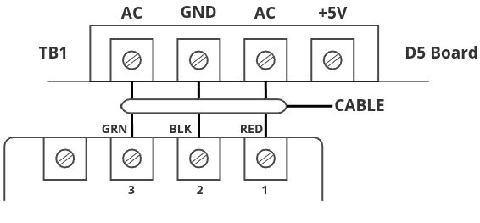Figure 1: 18V VAC Transformer Connection
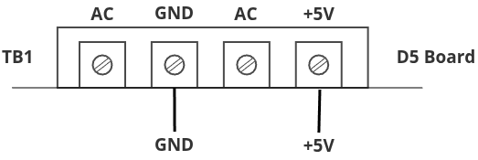Figure 2: External Supply Connection

2.6.2 User PIA
A 40-pin socket has been provided to allow an additional uncommitted
MC6821P in the D5. The PIA (U9) is supplied with the kit and the inter-
face signals are available at the 24-pin socket (U14).
TABLE 2.2. USER PIA CONNECTOR PINOUTS
Pin Number | Description | Pin Number | Description
1 | PA6 | 13 | GND
2 | PA7 | 14 | N.C.
3 | PB0 | 15 | PA5
4 | PB1 | 16 | PA4
5 | PB2 | 17 | PA3
6 | PB3 | 18 | PA2
7 | PB4 | 19 | PA1
8 | PB5 | 20 | PA0
9 | PB6 | 21 | CA2
10 | PB7 | 22 | NA1
11 | CB1 | 23 | N.C.
12 | CB2 | 24 | +5 V
2-5

2.6.2 User PIA (cont'd)
The IRQA and IRQB outputs of the user PIA may be connected to either
NMI or IRQ. Refer to the following figure while making connections.
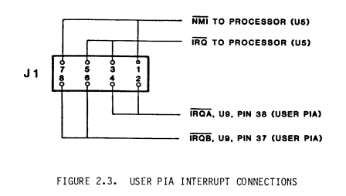
FIGURE 2.3. USER PIA INTERRUPT CONNECTIONS
The User PIA is decoded to appear at $E480.
PORT A ------------------------ $E480
DATA DIRECTION A -------------- $E480
CONTROL REG. A ---------------- $E481
PORT B ------------------------ $E482
DATA DIRECTION B -------------- $E482
CONTROL REG. B ---------------- $E483
2.6.3 Cassette
A 300 Baud Kansas City standard compatible cassette interface is pro-
vided for program storage. Most low-cost cassette recorders are com-
patible with the D5. The output from the cassette is connected to the
"EAR" input at P3 of the D5. Generally the higher the cassette output
level the better, but the D5 may accept as low as 2.0 Vpp.
To record programs connect the "MIC" output from P2 of the D5 to the
"MIC" input to the cassette recorder. The D5 sends a 50 mVpp signal
of 1200 Hz and 2400 Hz for zeroes and ones respectively.
2-6

2.7 Options
Several options are available for the user through installation or re-
moval of various jumpers or components. In general, addition of options
will require additional power which the on-board power supply may or may
not be capable of supplying. The limiting factor in the on-board supply
is the 7805 regulator heat dissipation characteristics. Some added
power capability can be achieved by going to a TO-3 type regulator which
can dissipate more heat. If the on-board regulator cannot supply enough
power for the added options, then E2 may be removed to disconnect this
regulator from the system allowing power to be supplied at the edge con-
nector, or through the four (4) terminal barrier block TB1.
2.7.1 User RAM
Provisions have been made to allow addition of 1K x 8 of User RAM. This
RAM is decoded to appear at addresses $E000 - $E3FF. To add this option
install (2) MCM2114 1K x 4 RAMs at U7 and U8.
2.7.2 User ROM
A 24-pin socket has been provided to allow the user to add an additional
ROM with its own firmware. Decoding is provided to allow this ROM to
appear at either of two areas in the memory map, $E800 to $EFFF or
$F800-$FFFF. If the user wishes the ROM to contain the system restart
and interrupt vectors, select the ROM at $F800-$FFFF and disable the
monitor ROM from mirroring there. The user then has full access to all
operating system routines but has priority during restart and interrupts.
In addition to selecting where this ROM will appear, the user can connect
the socket to accept various ROM or EPROM types. The following table
outlines the proper connections for the most common EPROM types.
TABLE 2.3. EPROM CONNECTIONS
Types | Organization | Pin 21 | Pin 20 | Pin 19 | Pin 18
MCM2708 | 1K x 8 | -5 V | /CS | +12 V | GND
TMS2716 | 2K x 8 | -5 V | A10 | +12 V | /CS
MCM2716 | 2K x 8 | +5 V | /CS | A10 | GND
Refer to the following figures for configuring the ROM sockets as
required. Figure 6.1, page 6-4 shows the location of these sockets.
2-7

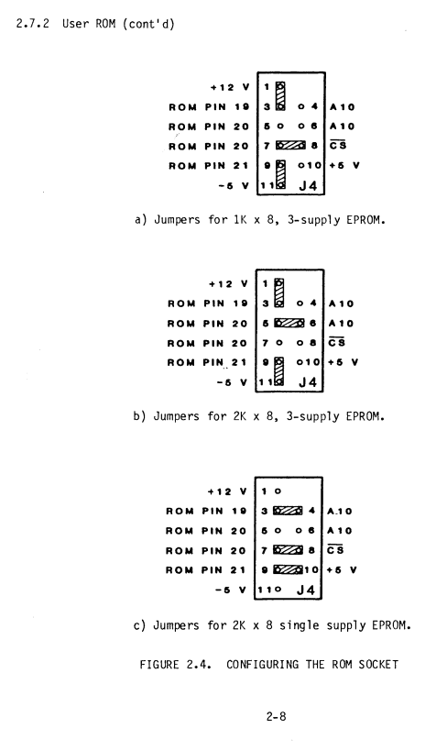

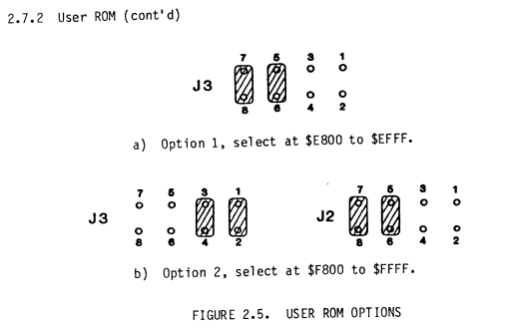

To use option 2 the system monitor mirror must be disabled by removing
the jumper between pins 1-2 of J2.
2.8 Bus Expansion
To expand the D5 through the 86-pin connector, install (2) 74LS244 octal
buffers at U1 and U2 and (1) 74LS245 octal bidirectional buffer at U3.
Also install a jumper at E1 to disable the MC6802's internal RAM.
2-9/2-10

CHAPTER 3
OPERATION
3.1 Common Terms and Notations
Microprocessors are digital devices which understand 1 (ones) and 0
(zeroes). In the MC6802 there is a 16-bit address bus and an 8-bit
data bus which communicate digitally (with binary 1's and 0's). It
becomes cumbersome to specify 16-bit addresses and 8-bit data in bi-
nary 1's and 0's so a shorthand code called hexadecimal is used.
Each hexadecimal digit (hex digit for short) represents (4) binary
bits.
In order to distinguish hex digits from ordinary decimal numbers, pre-
cede the hex number with a dollar sign ($). Sometimes it is very
obvious that a number is a hex number and the "$" symbol may be left
off as in program listings. In a binary number, the leftmost bit is
called the Most Significant Bit (MSB) and the rightmost bit is called
the Least Significant Bit (LSB).
Any group of 8-bits is called a "byte" and a group of 4-bits may be
called a "nibble". A "word" is a misleading term because many think
it means 8-bits, but "word" really refers to the size of the data word.
In most microprocessors the data bus just happens to be 8-bits wide but
there are exceptions such as the MC68000 which has a 16-bit "word" size.
Binary Number Hex Representation
0000 0
0001 1
0010 2
0011 3
0100 4
0101 5
0110 6
0111 7
1000 8
1001 9
1010 A
1011 B
1100 C
1101 D
1110 E
1111 F
Note: From 10 through 15 the letters A through F are used
for a single symbol to represent the 4-bit binary number.
3-1
3.1 Common Terms and Notations (cont'd)
Since 7-segment displays are used on the D5, the hex values A through F
are difficult to display. The letters B and D become lower case letters.
3.2 Display Indications
Step-by-step examples will show the resulting display. Notice there are
6 displays. In the examples a small letter x indicates "don't care";
that is it may not be possible to predict the actual value which will
appear but it indicates that the display will not be dark.
3.3 Keypad Entries and Displays
Located at the end of this chapter are detailed examples which will help
explain this section.
3.3.1 RESET
To reset the entire system, depress the "RS" button and the resulting
display will be a dash in the left hand position.
3.3.2 ESCAPE
Normally it is possible to abort a user program by depressing the "EX"
key; however, since this is dependent upon proper set-up of the keypad
PIA, it is possible for the user's program to disable the ESCAPE func-
tion.
Assuming a user program and the ESCAPE function active at the time the
"EX" key is depressed, the resulting display would reflect the current
user Program Counter status and the system would be in the register
display editor.
If the system was within the DEBUG operating system when "EX" was de-
pressed the resulting display would be a dash in the left hand position.
3.3.3 Miscellaneous
While entering numeric information, the first digit entry will clear the
entire register location being modified and the new digit will be rotated
into the least significant 4 bits of the register. Subsequent entries
will be shifted in from the right and there is no limit to the number of
digits which may be entered. When the next command key is depressed,
the value being displayed is the value which will be used.
3-2

3.3.3 Miscellaneous (cont'd)
When trying to GO to a user program, a check is performed to see that
the user's system stack can support the process of exiting to the pro-
gram. The method used to transfer control to the user program requires
that the user's register contents be put on the system stack and, if no
RAM exists at the "S" stack pointer location, then control cannot be
passed to the program. The display will be -SP- ??.
3.3.4 Memory Display/Change
To display or change the contents of a memory location, first enter the
hexadecimal address to be changed. Leading zeroes are not required and
digits may be entered until the display is correct. When this address
has been entered, depress the "M" key.
The first four display digits show the address of the memory location
being operated on. The fifth and sixth displays show the actual contents
of the displayed address and if they do not agree with the data entered,
it is an indication that the location is not properly accepting data.
To advance to the next higher memory location, depress "GO" and to back-
up to the next previous location, depress the "M" key.
3.3.5 Offset Calculation
To calculate a relative offset, depress "FS" from the memory display
change editor. The memory location being displayed at the time the "FS"
key was depressed is assumed to be the location of the offset byte. The
display at this point will be an A in the right most position,
prompting an entry of the destination address. After this address has
been entered, depress "GO". The offset will be calculated and checked
to see if it is within range of an 8-bit offset. The resulting dis-
play will be two numbers in the right most two displays or the letters
BAD indicating the offset was out of range. The numbers are an 8-bit
offset value.
Note this offset on the listing before continuing.
Depress "GO". The calculated offset is stored and control returned to
the memory display/change editor. The memory location being displayed
will be that immediately following the offset which was just stored.
3-3

3.3.5 Offset Calculation (cont'd)
If, for some reason, the calculated value should not be stored prior to
continuing, depress the "FC" key which will return control to the memory
display/change routine. The displayed memory location will be the same
one from which the offset calculation routine was called.
If the calculation was "BAD" depressing "M" will return to the memory
change editor.
3.3.6 Register Display/Alter
To get to register display, begin at the prompt point and depress "RD".
The first register displayed will be the user's program counter.
3.3.7 Summary of Register Display Formats
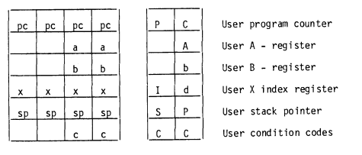
To advance to the next sequential register depress the "GO" key and to
back up to the next previous register depress the "M" key. The re-
gisters "wrap-around" so depressing "GO" while displaying CC, the next
display will be PC.
To change the contents of a psuedo register, just step to that display
and enter the desired value.
3.3.8 Trace Single Step
To trace a single MC6802 instruction, just depress "T/B" from within the
register display editor. After executing a single user instruction, the
operating system will regain control in the register display editor and
all registers will reflect the action of the executed instruction. De-
press "T/B" as many times as desired to execute that many instructions.
3-4

3.3.9 Go To User Program
To Go to a user program, start at the prompt point (a dash in the left
most display). Enter the address desired and then depress "GO".
3.3.10 Continue
This is like GO to user program except instead of specifying the GO
address, it is assumed to be the current value at the user program
counter pseudo register. To invoke this function, depress "GO" from
the "-" prompt point. It should not be necessary to enter any numbers
prior to "GO" to invoke the "CONTINUE" function.
3.3.11 Breakpoints
To enter the breakpoint editor, depress "FS" then "T/B" from the prompt
point.
To get out of the breakpoint editor, depress the "EX" key. To advance to
another breakpoint specification, depress "GO". The advance function
wraps around so successive presses of "GO" will eventually display all
breakpoints. Up to 5 breakpoints may be active at any time.
To de-activate an existing breakpoint, advance to where it is being dis-
played and depress "FC". The last digit of the display (# of break-
points) will decrement and another breakpoint will be displayed. To
remove all breakpoints, depress "FC" as many times as needed until the
"# of breakpoints" digit is zero.
To install a new breakpoint, enter its proposed hexadecimal address,
then depress "FS". Breakpoints will only be installed where there is a
RAM. If the "# of breakpoints" digit does not change, it is an in-
dication that the breakpoint could not be installed either because five
breakpoints already exist or because the breakpoint code ($3F) could
not be stored at the proposed address.
3.3.12 Punch
To punch a cassette tape, begin from the prompt (-) point. Depress
"P/L" and the display will be 0000 bb, prompting for a beginning address.
For example, depress 1, 2, 3. The display will be 0123 bb.
Depress GO to enter this address. The display will now be 0000 EE, as
a prompt to enter the last address of the data to be punched.
For example, depress 4, 5, 6, 7. The display will be 4567 EE.
3-5

3.3.12 Punch (cont'd)
Turn on the tape recorder in the RECORD mode and depress GO. A 30
second leader of $FF characters will preceed the data file.
When the punch process is complete, the prompt (-) returns and the D5
board is ready for the next command.
3.3.13 Load/Verify
The load command is "FS" then "P/L" while the verify command is "FS" -
"RD".
When the load or verify is completed without errors, the prompt re-
turns and the D5 is ready for the next command.
If an error occurred during load or verify, the message "Fail ??"
appears on the display. The user may escape at this point and enter
register display to find the error location. The address in error is
indicated by the value in the X-register. Also the data in the A-
register is the last byte read from the tape.
3.3.14 User Functions
User functions may be performed by use of the function set key and the
user function pointer (FNCPNT).
User functions are invoked by typing "FS" and a hex digit.
User functions are set up by providing a table of addresses of user
supplied functions, and by storing the address of the table at FNCPNT
Up to 16 functions may be added to the functions already on the D5.
3-6

Display and Programming Examples
These examples are given to illustrate programming techniques and applications
using the MEK6802D5.
Example to display 'USE D5'
- Determine the necessary 7-segment display codes required for the letters
and numbers to be displayed. This information is found in the detailed
description of the "PUT" routine in Chapter 7.
Symbol Binary Hex
U = 0011 1110 = $3E
S = 0110 1101 = $6D
E = 0111 1001 = $79
space = 0000 0000 = $00
d = 0101 1110 = $5E
5 = 0110 1101 = $6D
- Each symbol is listed with its binary equivalent and hex code keypad entry.
- The program listing entries are explained in the D5BUG listing (Chapter 7).
The complete program listing for this example is as follows (next page):

3-7
USEDS

0001 NAM USEDS
0002 OPT LLEN=80,CREF
0003A 0000 ORG $0
0004 * D5BUG ROUTINE
0005 E41D A DISBUF EQU $E41D
0006 F0A2 A DIDDLE EQU $F0A2
0007 E419 A MNPTR EQU $E419
0008 F0BB A PUT EQU $F0BB
0009 *
0010 *
0011A 0000 86 3E A BEG LDAA #$3E "U"
0012A 0002 B7 E41D A STAA DISBUF STORE TO FIRST DISPLAY
0013A 0005 86 6D A LDAA #$6D "S"
0014A 0007 B7 E41E A STAA DISBUF+1
0015A 000A 86 79 A LDAA #$79 "E"
0016A 000C B7 E41F A STAA DISBUF+2
0017A 000F 86 00 A LDAA #$00 BLANK
0018A 0011 B7 E420 A STAA DISBUF+3
0019A 0014 86 5E A LDAA #$5E "D"
0020A 0016 B7 E421 A STAA DISBUF+4
0021A 0019 86 6D A LDAA #$6D "5"
0022A 001B B7 E422 A STAA DISBUF+5 STORE TO LAST DISPLAY
0023A 001E CE F0A2 A LDX #DIDDLE ADDR OF DIDDLE ROUTINE
0024A 0021 FF E419 A STX MNPTR ESTABLISH AS ACTIVE SUB OF "PUT"
0025A 0024 7E F0BB A JMP PUT CALL DISPLAY ROUTINE
0026 END

ERRORS 00000--00000

0000 BEG 0011*
F0A2 DIDDLE 0006* 0023
E41D DISBUF 0005* 0012 0014 0016 0018 0020 0022
E419 MNPTR 0007* 0024
F0BB PUT 0008* 0025

After entering this program into memory using Memory Change, press
"0" and "GO" to begin execution.
Display and Programming Examples (cont’d)
Example to display ‘HELP --’
- Determine the 7-segment codes required, as in the previous example.
Symbol Binary Hex
H = 0111 0110 = $76
E = 0111 1001 = $79
L = 0011 1000 = $38
P = 0111 0011 = $73
- = 0100 0000 = $40
- = 0100 0000 = $40
- Each symbol is listed with its binary and hex codes equivalent.
- The program listing entries are explained in the D5BUG listing (Chapter 7).
The complete program listing for this example is as follows (next page):
3-9

HELP

0001 NAM HELP
0002 OPT LLEN=80,CREF
0003A 0000 ORG $0
0004 * D5BUG ROUTINES
0005 FCA2 A DIDDLE EQU $FCA2
0006 E41D A DISBUF EQU $E41D
0007 E419 A MNPTR EQU $E419
0008 F0BB A PUT EQU $F0BB
0009 *
0010 *

0011A 0000 CE 7679 A BEG LDX #$7679 "HE"
0012A 0003 FF E41D A STX DISBUF STORE TO FIRST 2 DISPLAYS
0013A 0006 CE 3873 A LDX #$3873 "LP"
0014A 0009 FF E41F A STX DISBUF+2
0015A 000C CE 4040 A LDX #$4040 "--"
0016A 000F FF E421 A STX DISBUF+4 STORE TO LAST 2 DISPLAYS
0017A 0012 CE FCA2 A LDX #DIDDLE ADDR OF DIDDLE ROUTINE
0018A 0015 FF E419 A STX MNPTR ESTABLISH AS ACTIVE SUB OF PUT
0019A 0018 7E F0BB A JMP PUT CALL DISPLAY ROUTINE
0020 END

0000 BEG 0011*
FCA2 DIDDLE 0005* 0017
E41D DISBUF 0006* 0012 0014 0016
E419 MNPTR 0007* 0018
F0BB

Display and Programming Examples (cont’d)
To help in better understanding the PUT/MNPTR routine operation, try the
following:
DIDDLE has been used so far as the subroutine which is executed once each
millisecond from PUT. Now substitute a long delay using the DLYX routine
as the subroutine which is specified by MNPTR.
0020 CE FFFF SLOW LDX #$FFFF For 1/2 second delay
0023 BD F179 JSR DLYX Delay
0026 39 RTS Then return to PUT
To install SLOW as the active subprogram of PUT, just change the third last
step of the "HELP --" program:
was:
0012 CE F0A2 LDX #DIDDLE Addr of DIDDLE routine
to:
0012 CE 0020 LDX #SLOW Addr of SLOW routine
When the program is running between successive digits (which are on for about
1 millisecond) there is an approximately half second delay.
Adjust the amount of delay by changing FFFF at 0021,2 and observe the effect.
This example is a clock program to display time in a 24-hour format. The
program is as follows (next page):
3-11

TIME

0001 NAM TIME
0002 OPT LLEN=80,CREF
0003A 0000 ORG $0
0004 * D5BUG ROUTINE
0005 F0BB A PUT EQU $F0BB
0006 E419 A MNPTR EQU $E419
0007 E42C A HEXBUF EQU $E42C
0008 F120 A DYSCOD EQU $F120
0009A 0000 0001 A RHR RMB 1 HOURS
0010A 0001 0001 A RMIN RMB 1 MINUTES
0011A 0002 0001 A RSEC RMB 1 SECONDS
0012A 0003 0002 A TICK RMB 2 COUNTERPASSES; ABOUT 1ms/PASS
0013 *

0014A 0005 CE 000E A START LDX #TIME ADDR OF TIME ROUTINE
0015A 0008 FF E419 A STX MNPTR ESTABLISH AS ACTIVE SUB
0016A 000B 7E F0BB A JMP PUT GET STARTED
0017 *

0018A 000E DE 03 A TIME LDX TICK # OF PASSES
0019A 0010 08 A INX INCREMENT # PASSES
0020A 0011 DF 03 A STX TICK UPDATE
0021A 0013 8C 0217 A CPX #535 PASSES/SEC
0022A 0016 26 4C 0064 BNE TBOT TO BOTTOM OF PROG
0023A 0018 CE 0000 A LDX #$0000
0024A 001B DF 03 A STX TICK RESET TICK COUNT
0025A 001D 7C 0002 A INC RSEC INCREMENT SECONDS
0026A 0020 96 02 A LDAA RSEC
0027A 0022 8A F5 A ORAA #$F5 CHECK FOR BCD OVERFLOW
0028A 0024 43 COMA
0029A 0025 26 3D 0064 BNE TBOT IF NOT $xA SECONDS
0030A 0027 96 02 A LDAA RSEC
0031A 0029 8B 06 A ADDA #6 INCREMENT TENS DIGIT
0032A 002B 97 02 A STAA RSEC UPDATE
0033A 002D 81 60 A CMPA #$60 60 SEC YET ?
0034A 002F 26 33 0064 BNE TBOT IF NOT; EXIT
0035A 0031 7F 0002 A CLR RSEC RESET SECONDS COUNT
0036A 0034 7C 0001 A INC RMIN NEW MINUTE
0037A 0037 96 01 A LDAA RMIN
0038A 0039 8A F5 A ORAA #$F5 CHECK FOR BCD OVERFLOW
0039A 003B 43 COMA
0040A 003C 26 26 0064 BNE TBOT IF NOT; EXIT
0041A 003E 96 01 A LDAA RMIN
0042A 0040 8B 06 A ADDA #6 INCREMENT TENS DIGIT
0043A 0042 97 01 A STAA RMIN UPDATE
0044A 0044 81 60 A CMPA #$60 60 MIN YET ?
0045A 0046 26 1C 0064 BNE TBOT IF NOT; EXIT
0046A 0048 7F 0001 A CLR RMIN RESET MINUTES COUNT
0047A 004B 7C 0000 A INC RHR NEW HOUR
0048A 004E 96 00 A LDAA RHR
0049A 0050 8A F5 A ORAA #$F5 CHECK FOR BCD OVERFLOW
0050A 0052 43 COMA
0051A 0053 26 06 005B BNE CHKHR CHECK FOR END OF A DAY
0052A 0055 96 00 A LDAA RHR
0053A 0057 8B 06 A ADDA #6 INCREMENT TENS DIGIT
0054A 0059 97 00 A STAA RHR UPDATE HOURS
0055A 005B 96 00 A CHKHR LDAA RHR
0056A 005D 81 24 A CMPA #$24 END OF A DAY ?
0057A 005F 26 03 0064 BNE TBOT
0058A 0061 7F 0000 A CLR RHR RESET HOURS

3-12
TIME

0059A 0064 DE 00 A TBOT LDX RHR HOURS/MINUTES
0060A 0066 FF E42C A STX HEXBUF TO HEX BUFFER
0061A 0069 96 02 A LDAA RSEC SECONDS
0062A 006B B7 E42E A STAA HEXBUF+2 TO LAST DIGITS
0063A 006E 7E F120 A JMP DYSCOD CONVERT TO 7-SEG
0064 * YOU WILL RETURN TO PUT AT CONCLUSION OF DYSCOD
0065 END

ERRORS 00000--00000

005B CHKHR 0051 0055*
F120 DYSCOD 0008* 0063
E42C HEXBUF 0007* 0060 0062
E419 MNPTR 0006* 0015
F0BB PUT 0005* 0016
0000 RHR 0009* 0047 0048 0052 0054 0055 0058 0059
0001 RMIN 0010* 0036 0037 0041 0043 0046
0002 RSEC 0011* 0025 0026 0030 0032 0035 0061
0005 START 0014*
0064 TBOT 0022 0029 0034 0040 0045 0057 0059*
0003 TICK 0012* 0018 0020 0024
000E TIME 0014 0018*

After entering this program into memory using Memory Change, press
"5" and "GO" to begin execution.

3-13
Comments on 24 hour clock program "TIME"
The technique used to measure time is called "software timing" and relies on
the system clock accuracy and the sum of the execution times on all of the
instructions being performed. This is a cumbersome technique to do right.
Determine all the different paths through the program in order to accurately
predict the program's total execution time.
This is precisely the technique used in some digital watches, but in that
case there is a fine adjustment to tune the clock frequency to better than
.001% which comes out to about 5 minutes per year. In a typical micropro-
cessor system, the clock speed is not adjustable and accuracy is about 0.1%
which comes out to more than a minute a day.
As for calculating actual program execution time, look at the program to see
how many different paths there are just from the label "TIME" to "TBOT":
- Not end of tick.
- End of tick, not end of minute, not a tenth second.
- End of tick, not end of minute, second tens digit incr.
- End of tick, end of minute, not end of hour, not a tenth minute.
- End tick, end minute, not end hour, minute tens digit incr.
- End tick, end minute, end hour, not end day, not a tenth hour.
- End tick, end minute, end hour, end day.
Each of the above paths through the TIME program takes a different length of
time because a different sequence of instructions is followed. That's just
part of the task; to completely calculate the execution time, do the same
thing to every routine being executed. Then to find the total, determine exactly how many times each path is followed and add up all those times.
CHAPTER 4
THEORY OF OPERATION
4.1 General
The MEK6802D5 allows the user to become familiar with the MC6800 family
of microprocessors. Refer to the block diagram, Figure 4.1, and the
component function location diagram, Figure 4.2.
The three basic components of the D5 are (1) U5, the MC6802 micro-
processor, (2) U12, the MC68A1316E ROM, and (3) U23, the MC6821 PIA.
The MC6802 is the heart of the D5 system. The MC6802 is an eight (8)-
bit microprocessor that can execute 72 different instructions (exact
instruction set of the MC6800). Included are binary and decimal arith-
metic, logical, shift, rotate, load, store, conditional or unconditional
branch, interrupt and stack manipulation instructions.
The MC6802 has a set of registers and accumulators plus an internal
clock oscillator and driver.
For a more detailed explanation and description of the MC6802 Micro-
processor refer to the data sheet located at the end of this manual.
The MEK6802D5 utilizes a 3.58 MHz crystal (Y1) to control this cir-
cuitry (this results in a system operating speed of 895 KHz). Power
on/reset is accomplished by components R1 and C17.
Basic to the operation of the D5 system is the Data bus (eight lines
labeled BD0 through BD7) and the Address bus (sixteen lines labeled
BA0 through BA15). These buses interconnect to the various sections.
The address bus is further decoded by the Address Decode Logic (U6)
into select lines. J2 and J3 must be set properly to accomplish this.
These jumpers are specified in the installation section of this manual
for the various board arrangements possible.
The ROM section is the permanent data storage. Unlike some types of
memories, this ROM retains data whether the power is on or not.
The ROM section consists of the D5BUG Monitor (U12) and the optional
User ROM (U13). J4 is used to configure the user ROM socket to accept
various types of ROMs or EPROMs. J2 is used to position U13 (user ROM)
in memory space. J3 is used to position U12 (D5BUG) in memory space.
The RAM section consists of a 128 byte static Random Access Memory.
This memory will retain its stored data as long as power is supplied
to it and can be written into and read out of as desired.
4-1

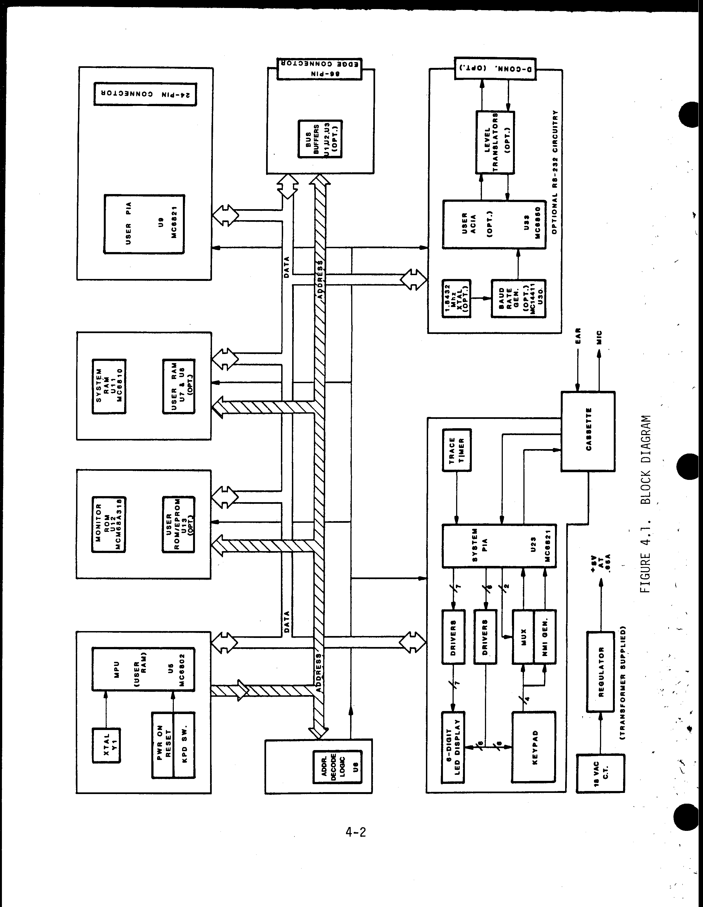

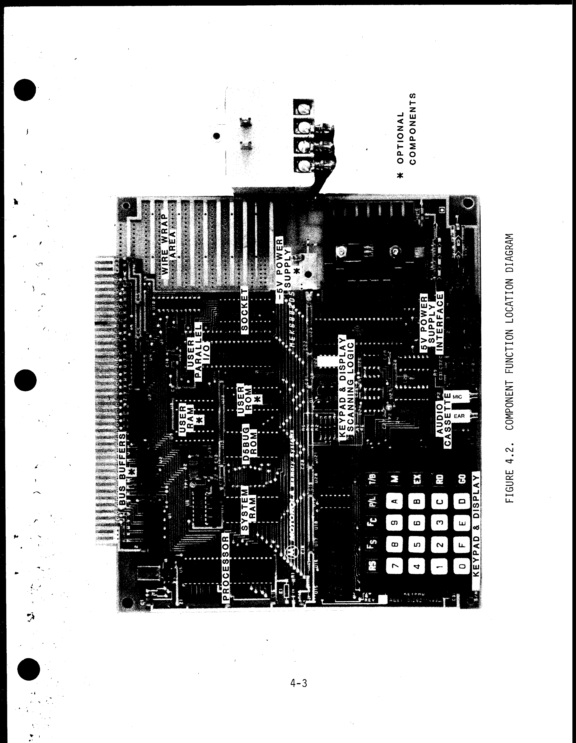
The D5 uses this RAM as a Scratch Pad, which is a temporary storage for
program material being processed. An example of this could be a program
that uses a set of data a large number of times during the running of the whole program. This device would allow that data to be referred to as needed, rather than being repeated over again in the main program.
Another optional feature is the User RAM (U7 and U8). This provides the
user with an additional (1K) bytes of memory. This feature is valuable
when long programs must be stored.
These memories are volatile, and power must be supplied to them to retain their stored data.
The system PIA has two 8-line I/O ports and four control I/O lines for a
total of 20 interface lines. The four control lines provide for a variety of hand shake applications. The two I/O ports are controlled by software to configure these 16 lines as inputs or outputs in any combination.
The User PIA (U9), allows the processor to talk to the outside world. The 16 I/O lines and 4 control lines are connected to a 24-pin socket (U14).
The optional Bus Buffers (U1, U2, U3) are for expanding the D5 through an 86-pin edge connector. This is accomplished by plugging an IC in the
supplied sockets. Note that U10, also a bus driver, is part of the basic D5 since the processor's R/W output cannot drive all the inputs in the basic system (or the bus). All the control signals, data, and addresses are available on this bus for system expansion.
The system PIA, (U23) uses its A side to drive the anode segments of the
LED displays and the B side to drive the LED cathodes. The processor put data into the register of the PIA to display on one of the LED's, then places data in the PIA registers to drive the next display element, etc., at a rapid enough rate that the display appears steady.
The keypad is connected to the cathode drivers of the LED's so that when
a key is depressed, an interrupt signal is generated. This interrupt
signal causes the processor to call up a routine from D5BUG, which then
enables it to search for the key that was closed. The PIA is used to
enter new data or display data in the system.
The D5 can be supplied to interface to the widely used RS-232 bus.
An Asynchronous Communications Interface Adapter (ACIA) converts the par-
allel data on the data bus to a serial form suitable for transmission
4.1 General (cont'd)

over a communications system. This ACIA will both transmit and receive
data and allows the D5 to be used as a remotely controlled processor. An
MC14411 Bit Rate Generator supplies the special frequency that the ACIA
requires in making the conversion from parallel to serial data.

An installed jumper determines the frequency of data formatted in serial
form. A socket allows cabling to the RS-232 line.

4.2 Addressing

The MEK6802D5 accesses 64K of memory space by use of 16 address lines
A0 through A15. The addresses $E000 to $FFFF access parts on the
MEK6802D5 and external data buffers are not enabled for such accesses.
The area from $0000 to $007F is RAM within the MC6802 and must be dis-
abled by jumper option if the optional bus buffers are installed.

When the optional edge connector bus buffers are installed, all accesses
to addresses $0000 to $DFFF are considered to be off-board.

The system memory map is shown in Figure 4.3, the Address Decode Map in
Table 4.1 and the System Timing Diagram in Figure 4.4.

4-5
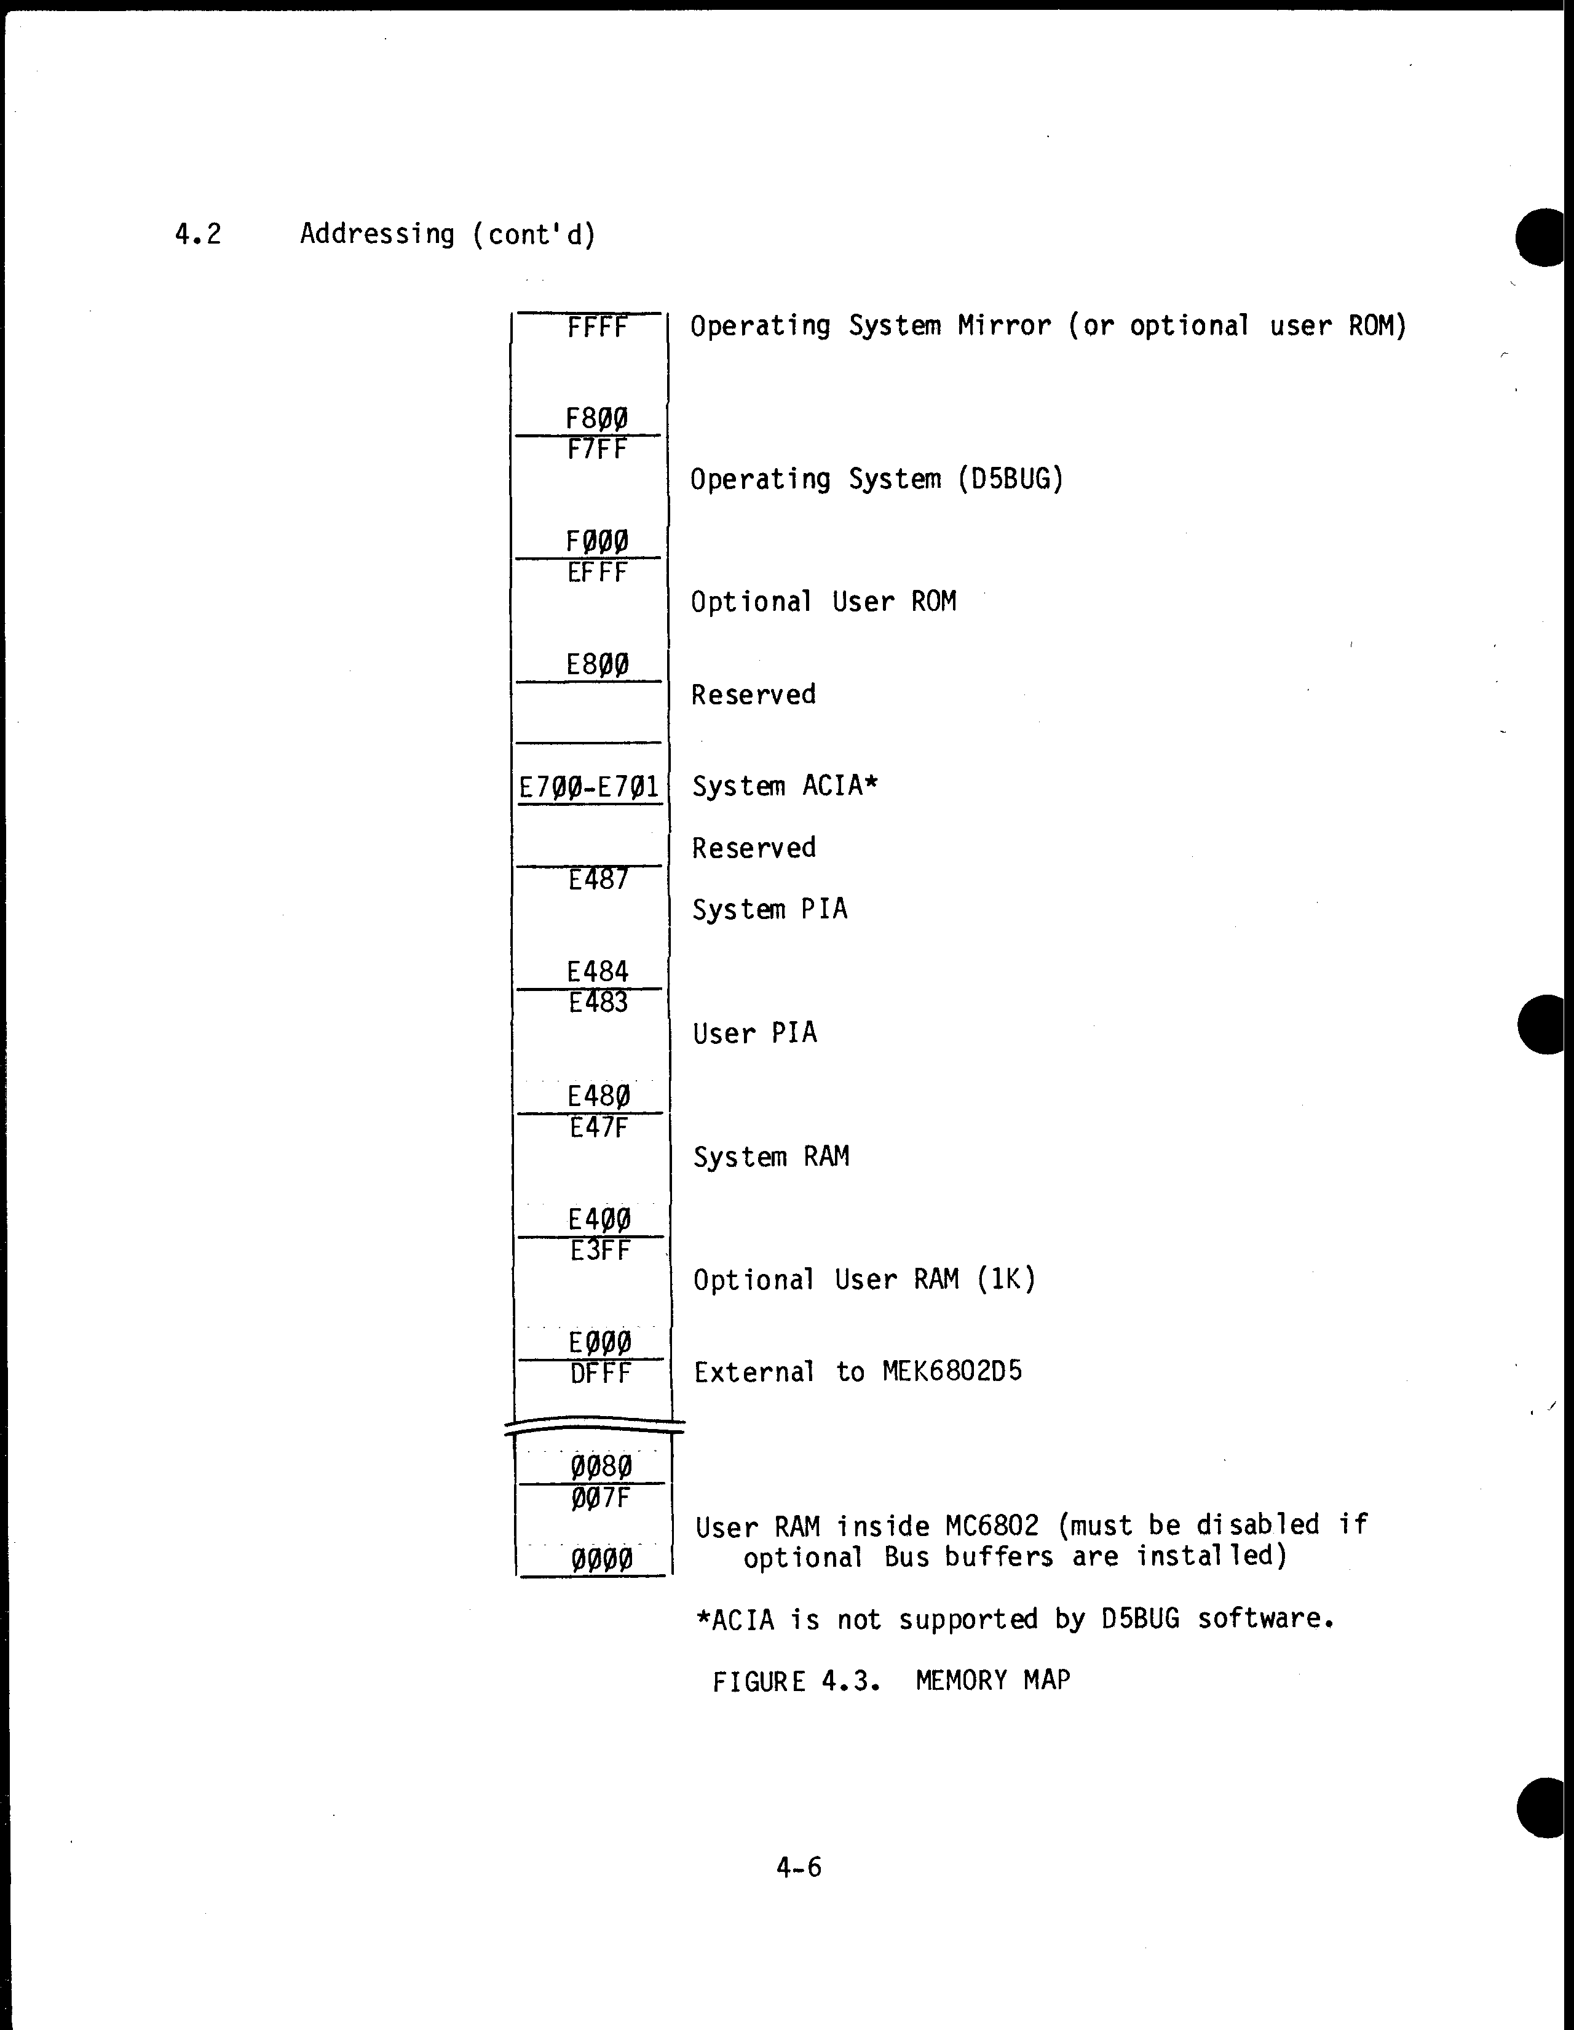
TABLE 4.1. ADDRESS DECODE MAP
User ROM (Opt.-5 | VMA | R/W | A15 | A14 | A13 | A12 | A11 | A10 | A9 | A8 | A7 | A6 | A5 | A4 | A3 | A2 | A1 | A0 | U No.
User ROM (Opt.-4 | 1 | X | 1 | 1 | 1 | 1 | * | . | . | . | . | . | . | . | . | . | . | . | U12
User ROM (Opt.-3 | 1 | . | 1 | 1 | 1 | 0 | 0 | 1 | 0 | 0 | 0 | . | . | . | . | . | . | . | U11
User ROM (Opt.-2 | 1 | . | 1 | 1 | 1 | 0 | 0 | 1 | X | X | 1 | X | X | X | X | 0 | . | . | U9
User ROM (Opt.-1 | 1 | . | 1 | 1 | 1 | 0 | 0 | 1 | X | X | 1 | X | X | X | X | 1 | . | . | U23
User ROM (Opt.0 | 1 | . | 1 | 1 | 1 | 0 | 0 | 0 | . | . | . | . | . | . | . | . | . | . | U7,U8
User ROM (Opt.1) | 1 | . | 1 | 1 | 1 | 0 | 1 | . | . | . | . | . | . | . | . | . | . | . | U13
User ROM (Opt.2) | 1 | . | 1 | 1 | 1 | ** | 1 | . | . | . | . | . | . | . | . | . | . | . | U13
User ROM (Opt.3 | 1 | . | 0 | 0 | 0 | 0 | 0 | 0 | 0 | 0 | . | . | . | . | . | . | . | . | U5
User ROM (Opt.4 | 1 | . | 1 | 1 | 1 | 0 | 0 | 1 | 1 | 1 | 1 | 0 | X | X | X | X | X | X | U33
User ROM (Opt.5 | 1 | . | $0000 - $DFFF (Must install E1) |  |  |  |  |  |  |  |  |  |  |  |  |  |  |  | U3

Legend:
0 - Logic zero 1 - Logic one . - Both X - Don't Care
* - Normally both but by removing jumpers it becomes 0 only.
** - 1 but monitor mirror must be disabled.
***- Inherent to the MC6802 by design, may be disabled for system expansion.
TABLE 4.2. AC OPERATING CHARACTERISTICS
TABLE 4.2. AC OPERATING CHARACTERISTICS

TABLE 4.2. AC OPERATING CHARACTERISTICS
Parameter | Symbol | Min | Max | Unit
Cycle | TCYC | 1100 | 1130 | ns
Address Setup | TAS | 220 |  | ns
Address Hold | TAH | -20 |  | ns
Write Data Valid | TDVW |  | 240 | ns
Write Data Hold | TDHW | 20 |  | ns
Address Delay | TAD |  | 290 | ns

TABLE 4.3. AC OPERATING CONDITIONS
Parameter | Symbol | Min | Max | Unit
Access Time⁴ | TACC1 |  | 380 | ns
 | TACC2 |  | 710 | ns
Data Hold Read⁵ | TDHR | 0 |  | ns

Test Conditions:
- Operating temperature, TA = 25°C.
- Timing signals measured at I/O connector (50% points).
- I/O loading conditions equivalent to 74LS type devices.
- Measured from the rising edge of E (Ø2).
- Measured from the falling edge of E (Ø2).
4-8

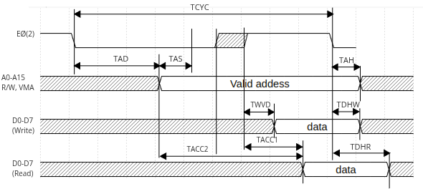Figure 3: System Timing Diagram
CHAPTER 5
MAINTENANCE
5.1 Troubleshooting
Troubleshooting techniques can be divided into several steps:
a) Check and analyze operation.
b) Test to isolate section, stage, and part.
c) Replace the defective part.
d) Performance test after repair.
For all troubleshooting, refer to the system schematic, Figure 5.1, and
to the component location diagram, Figure 6.1, in Chapter 6.
Begin troubleshooting by checking the power supply voltages used with the
D5. Check for secure and correct transformer connections.
The 86-pin edge connector fingers are tin lead plated and should be
cleaned for reliable operation.
Use caution when replacing defective parts. Improper handling (refer to
Chapter 2) and too much heat can destroy components.
5.2 Standard Logic Symbols
5.2.1 Digital Logic Circuits
All digital equipment, simple or complex, is constructed from a few
basic devices. These devices consist of electronic circuitry that pro-
vides an output based on the input of one, two, or more variables and
are called logic elements (most often referred to as gates).
Digital logic circuits are broken into two basic types: decision-
making and memory elements. All decision logic elements monitor binary
inputs and produce outputs based on the input states and the operational
characteristics of the logic element. Memory elements are used to
store binary data. Table 5.1 gives the basic logic elements, their
more commonly used forms, and their single binary output. All other
digital logic elements and circuits are variations or combinations of
these basic elements.
5-1

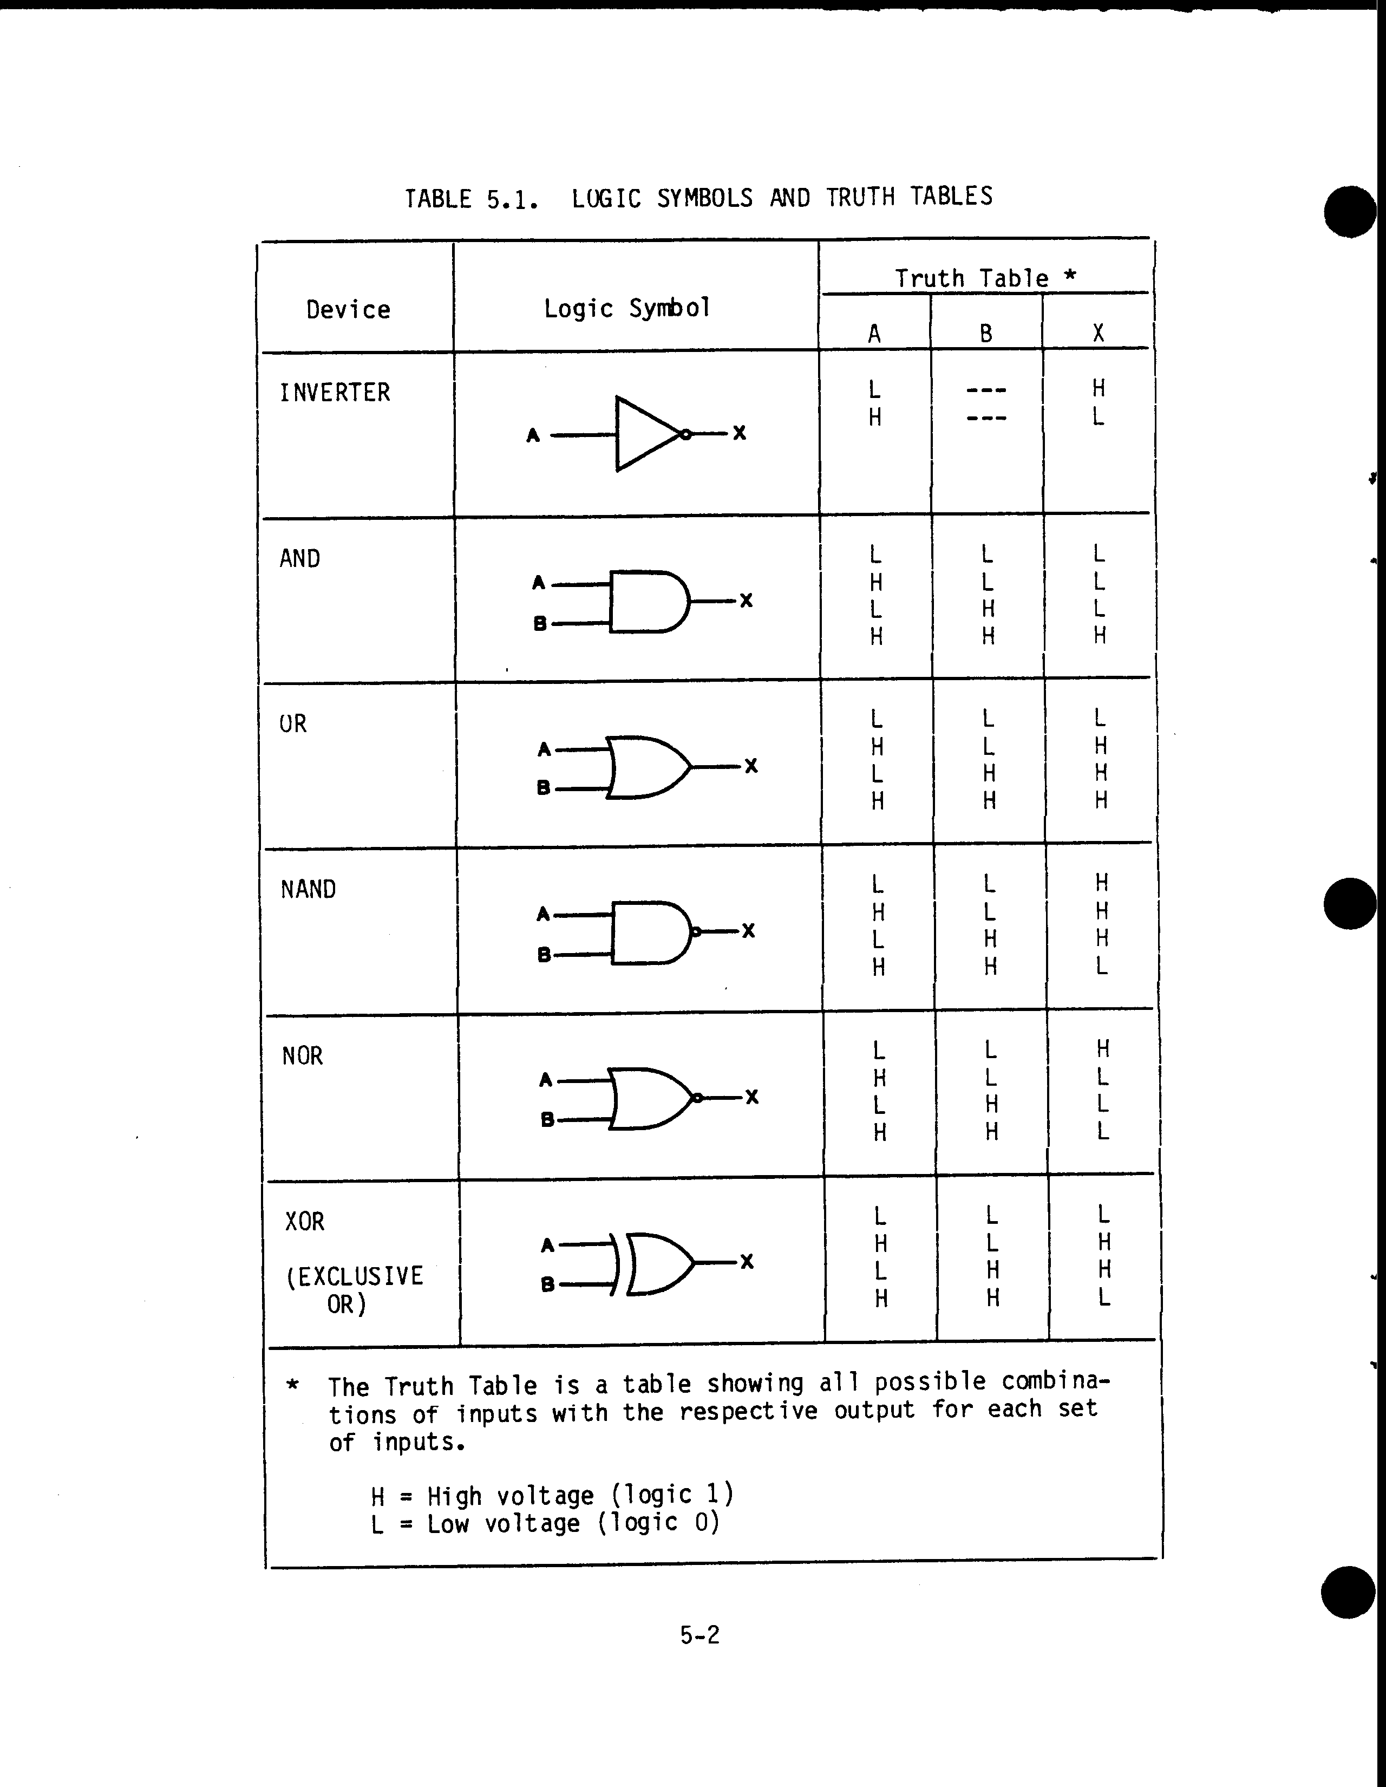
FIGURE 5.1. SCHEMATIC DIAGRAM
Sheet 1: Index Page
Sheet 2: Schematic Diagram
Sheet 3: Schematic Diagram
NOTE: This is sheet 1 of Figure 5.1. The
schematic diagram consists of 2 sheets.
5-3/5-4

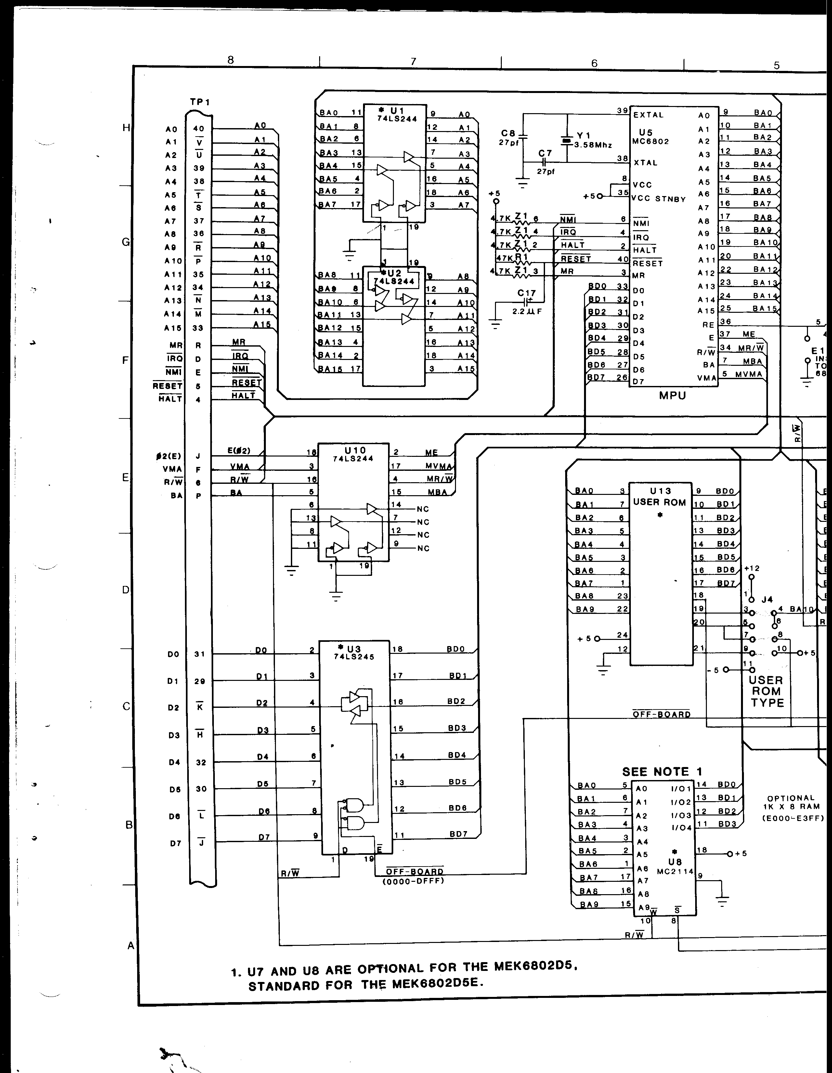
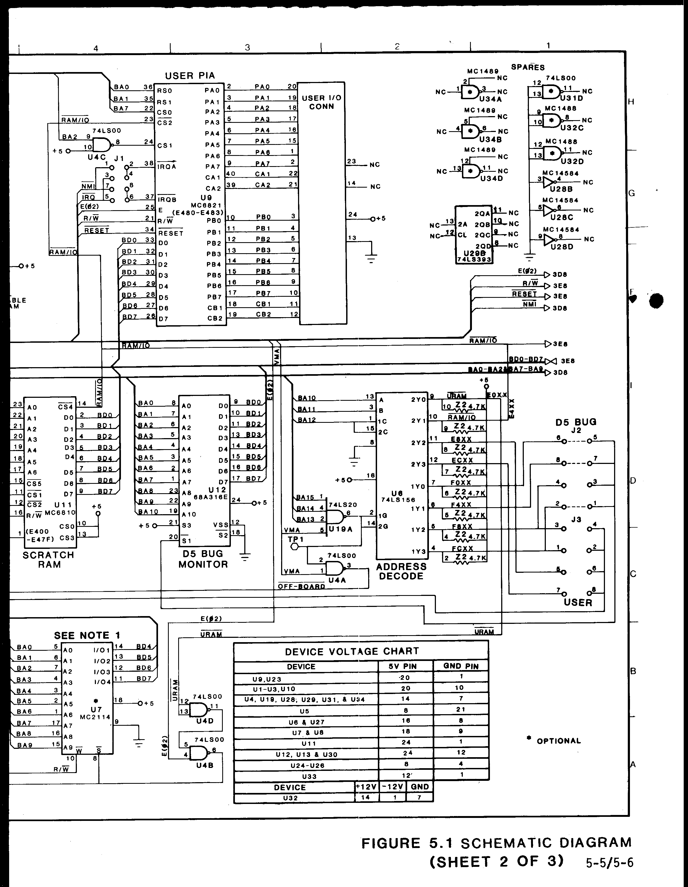
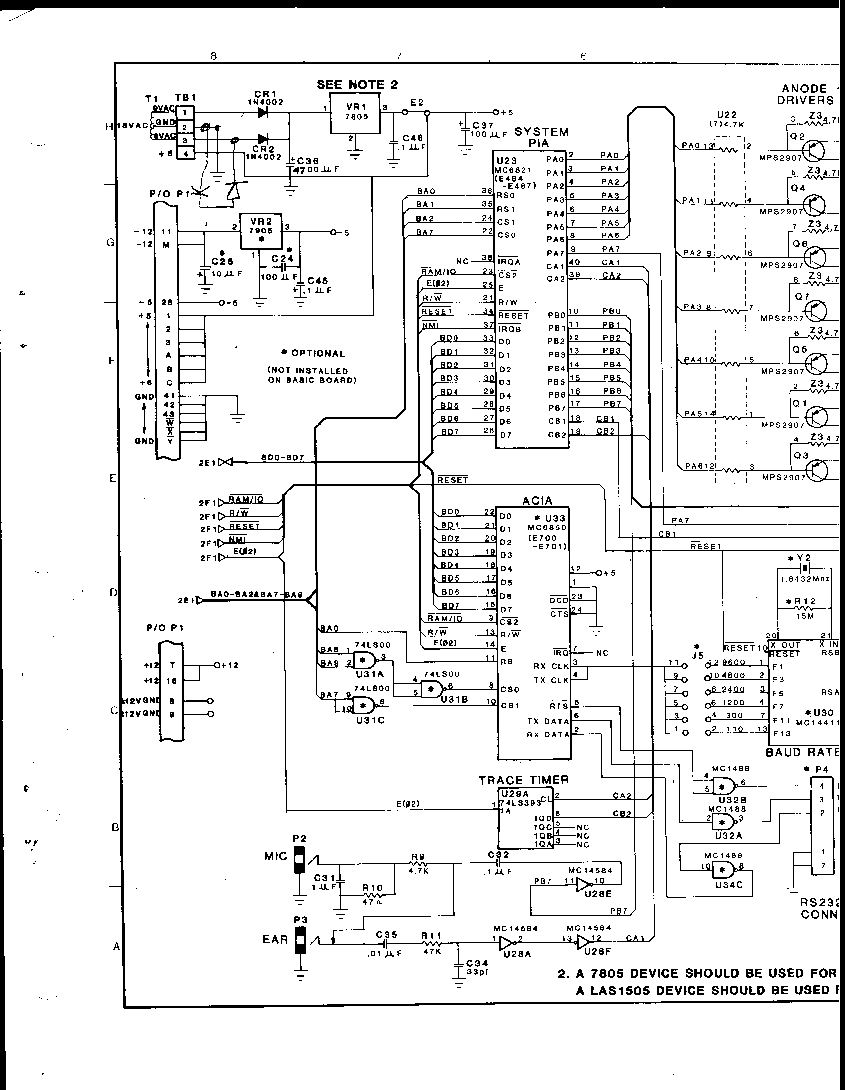
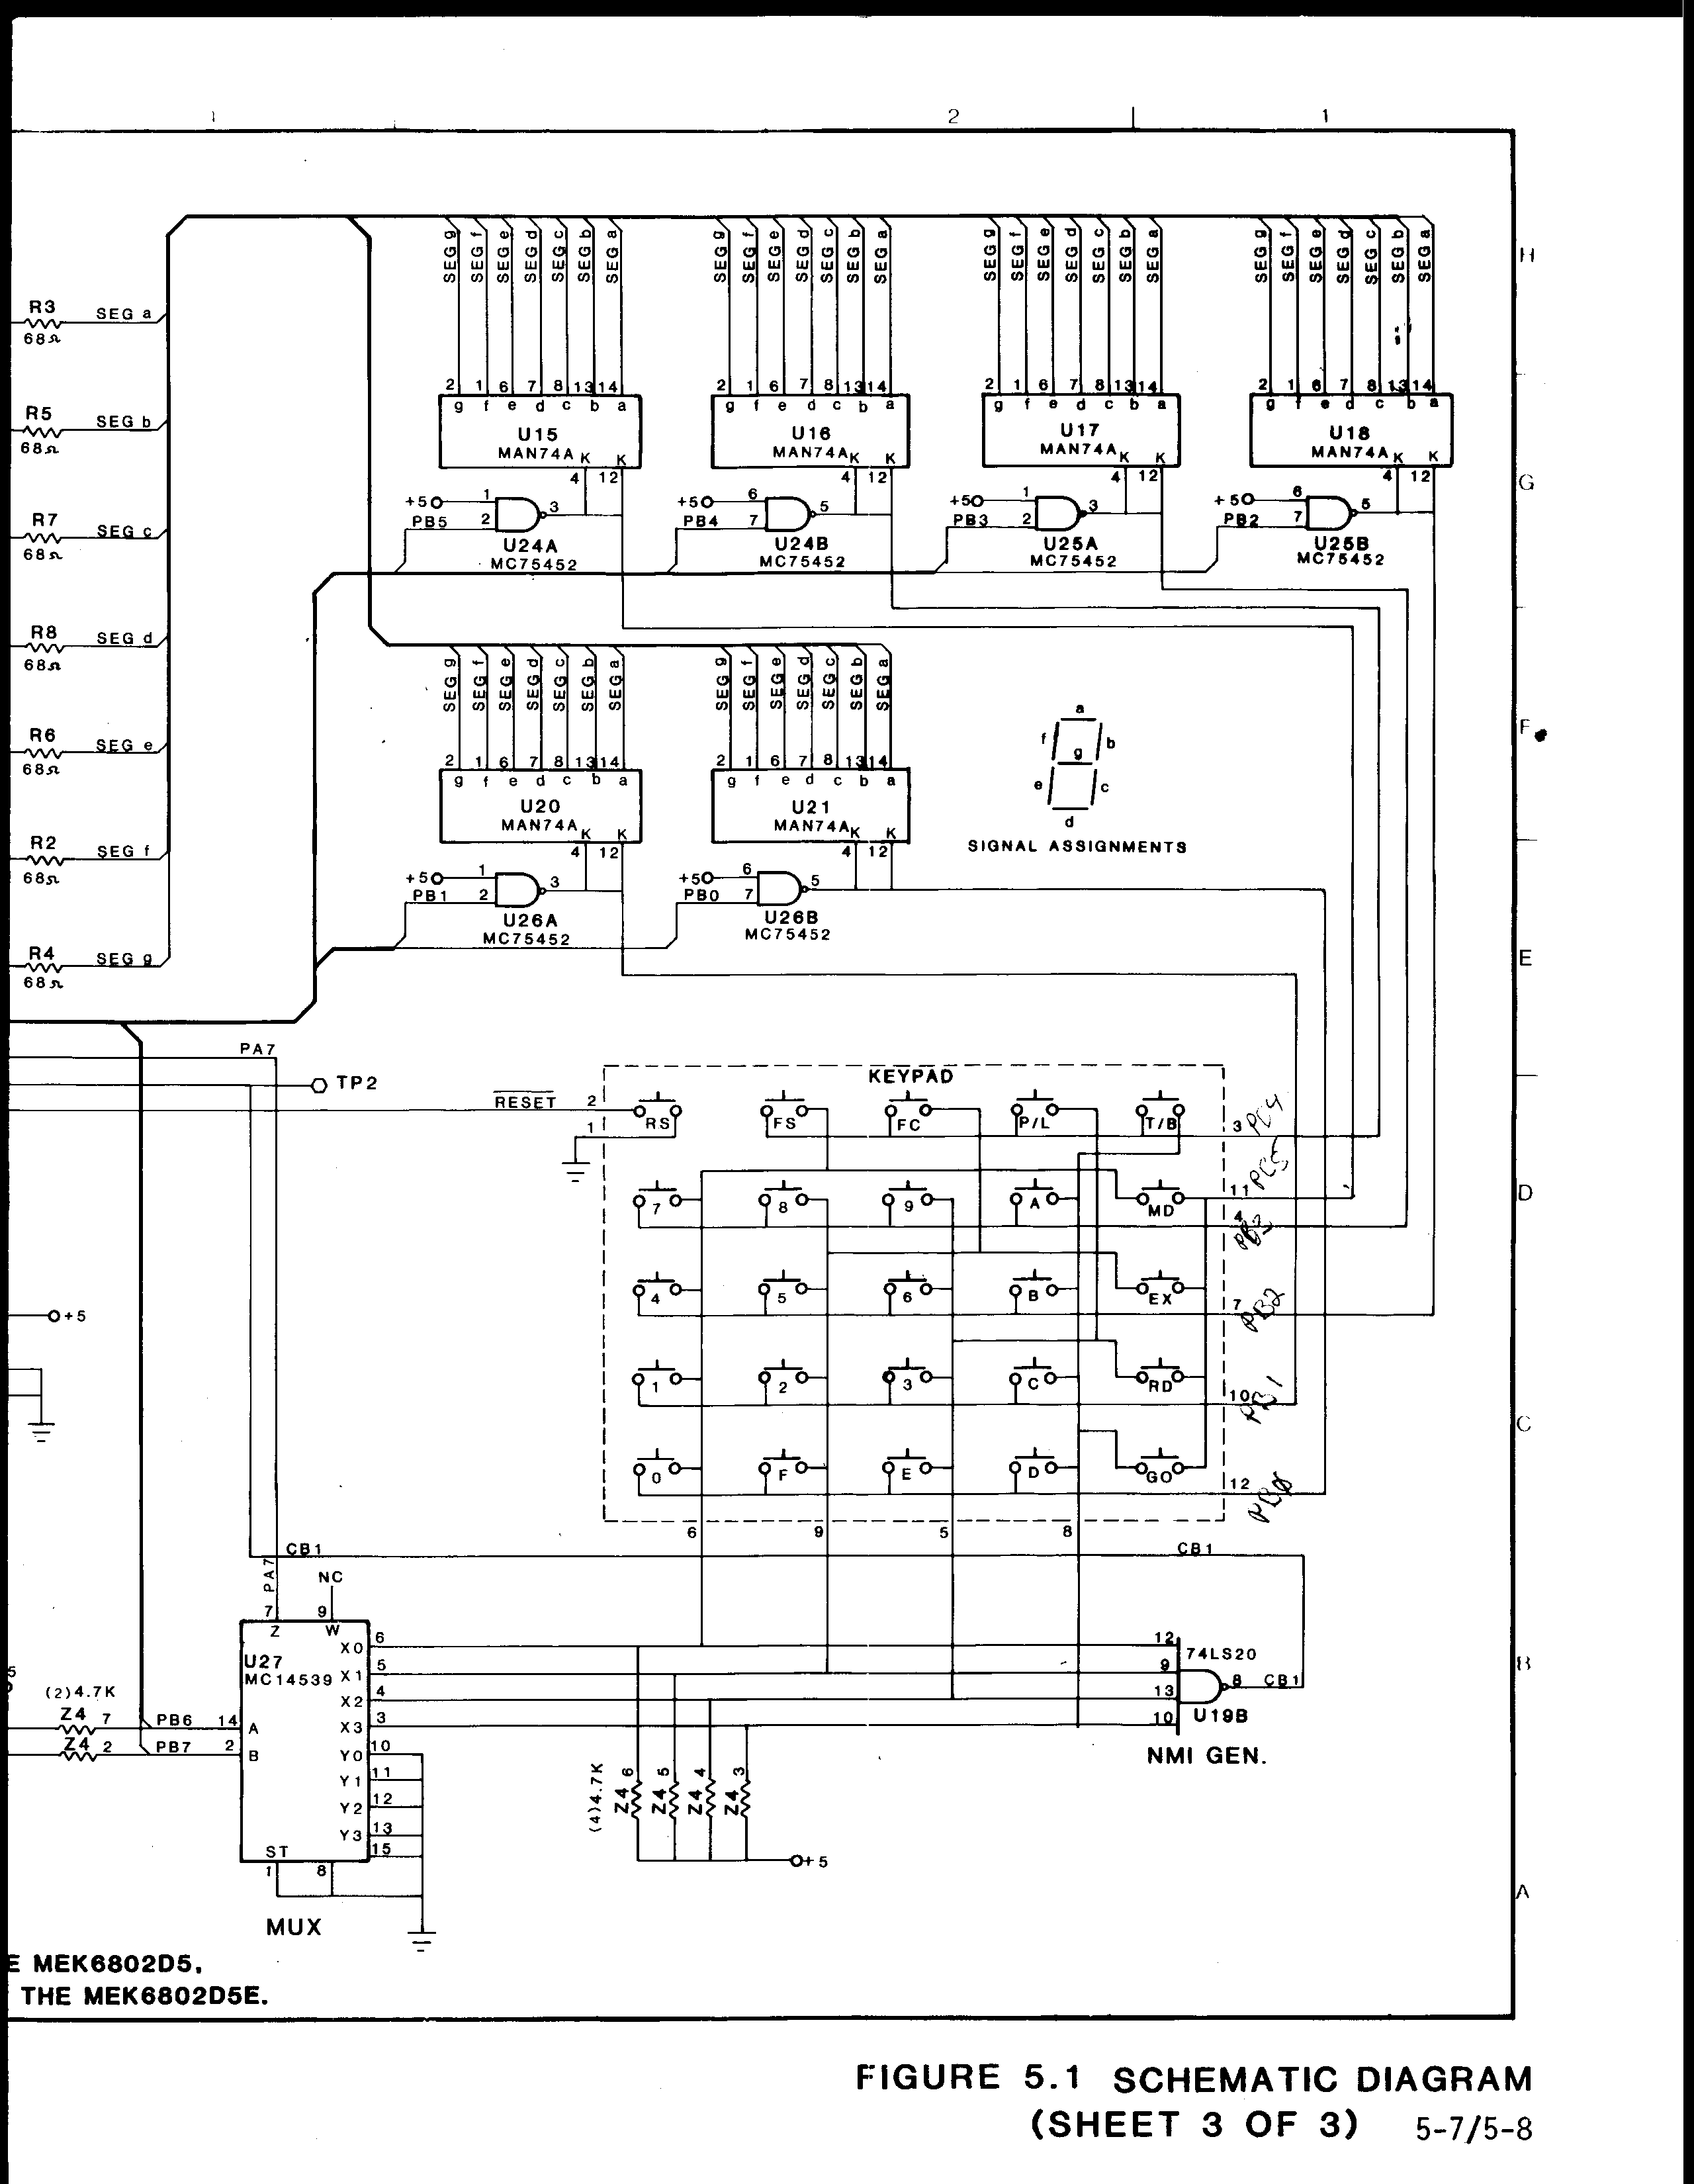
CHAPTER 6
PARTS LIST
6.1 General
This chapter consists of Figure 6.1, Board Outline and Component Layout,
and Table 6.1, which is a listing of parts contained in the MEK6802D5
Microcomputer.
TABLE 6.1. MEK6802D5 PARTS LIST

Item No. | Quan. | Description | Part Number | Reference Designation
1 | 1 | PC Board, Basic | MEK6802D5 | --
2 | 1 | Integrated Circuit | MCM68A316E | U12 (D5BUG)
3 | 1 | Integrated Circuit | 74LS00 | U4
4 | 1 | Integrated Circuit | 74LS20 | U19
5 | 1 | Integrated Circuit | 74LS156 | U6
6 | 1 | Integrated Circuit | 74LS393 | U29
7 | 1 | Integrated Circuit | MC6802 | U5
8 | 2 | Integrated Circuit | MC6821P | U23, U9
9 | 1 | Integrated Circuit | MC6810 | U11
10 | 3 | Integrated Circuit | 75452 | U24, U25, U26
11 | 1 | Integrated Circuit | MC14539 | U27
12 | 1 | Integrated Circuit | 74LS244 | U10
13 | 1 | Integrated Circuit | MC14584 | U28
14 | 1 | Resistor, 4.7K1/4 Watt, 5% |  | R9
15 | 1 | Resistor, 47 ohm1/4 Watt, 5% |  | R10

TABLE 6.1. MEK6802D5 PARTS LIST (cont’d)

Item No. | Quan. | Description | Part Number | Reference Designation
16 | 2 | Resister, 47K1/4 Watt, 5% |  | R1, R11
17 | 7 | Resister, 68 ohm1/4 Watt, 5% |  | R2, R3, R4, R5, R6, R7, R8
18 | 3 | Resister Package,SIP, 4.7K |  | Z1, Z3, Z4
19 | 1 | Resister Package,SIP, 4.7K |  | Z2
20 | 1 | Resister Package,DIP, 4.7K |  | U22
21 | 1 | Capacitor, 33 pF,Mica |  | C34
22 | 1 | Capacitor, 0.01 uF,Mono (ceramic) |  | C35
23 | 2 | Capacitor, 27 pF,Mica |  | C7, C8
24 | 30 | Capacitor, 0.1 uF,Mono (ceramic) |  | C1-C6, C9-C16, C18-C23, C26-C30, C32, C33, C38, C45, C46
25 | 1 | Capacitor, 100 uF,35 V, Elect |  | C37
26 | 1 | Capacitor, 2.2 pF |  | C17
27 | 1 | Capacitor, 1.0 uF,Mono (ceramic) |  | C31
28 | 1 | Capacitor, 4700 uF,16 V |  | C36
29 | 3 | Socket, IC, 20-pin |  | U1-U3
30 | 2 | Socket, IC, 18-pin |  | U7-U8

Item No. | Quan. | Description | Part Number | Reference Designation
31 | 4 | Socket, IC, 24-pin |  | U11-U14
32 | 3 | Socket, IC, 40-pin |  | U5, U9, U23
33 | 3 | Mini-jump |  | J2
34 | 2 | Phone Jack, Enclosed |  | P2, P3
35 | 2 | Test Point, White |  | TP1, TP2
36 | 1 | Crystal, 3.579 MHz |  | Y1
37 | 1 | Waffer Assy, 6 |  | J4
38 | 7 | Waffer Assy, 4 |  | J1-4
39 | 6 | LED, 7-segment | Man 74A | U15-U18, U20-U21
40 | 1 | Hex Keypad
41 | 1 | Transformer |  | T1
42 | 1 | Cable Assy,3 Conductor
43 | 1 | Terminal Block,4 Position |  | TB1
44 | 1 | Voltage Regulator+5 V | 7805 | VR1
45 | 2 | Diode | 1N4002 | CR1, CR2
46 | 1 | Jumper, Zero ohm |  | E2
47 | 7 | Transistor | MPS 2907 | Q1-Q7
48 | 1 | Heat Sink |  | VR1

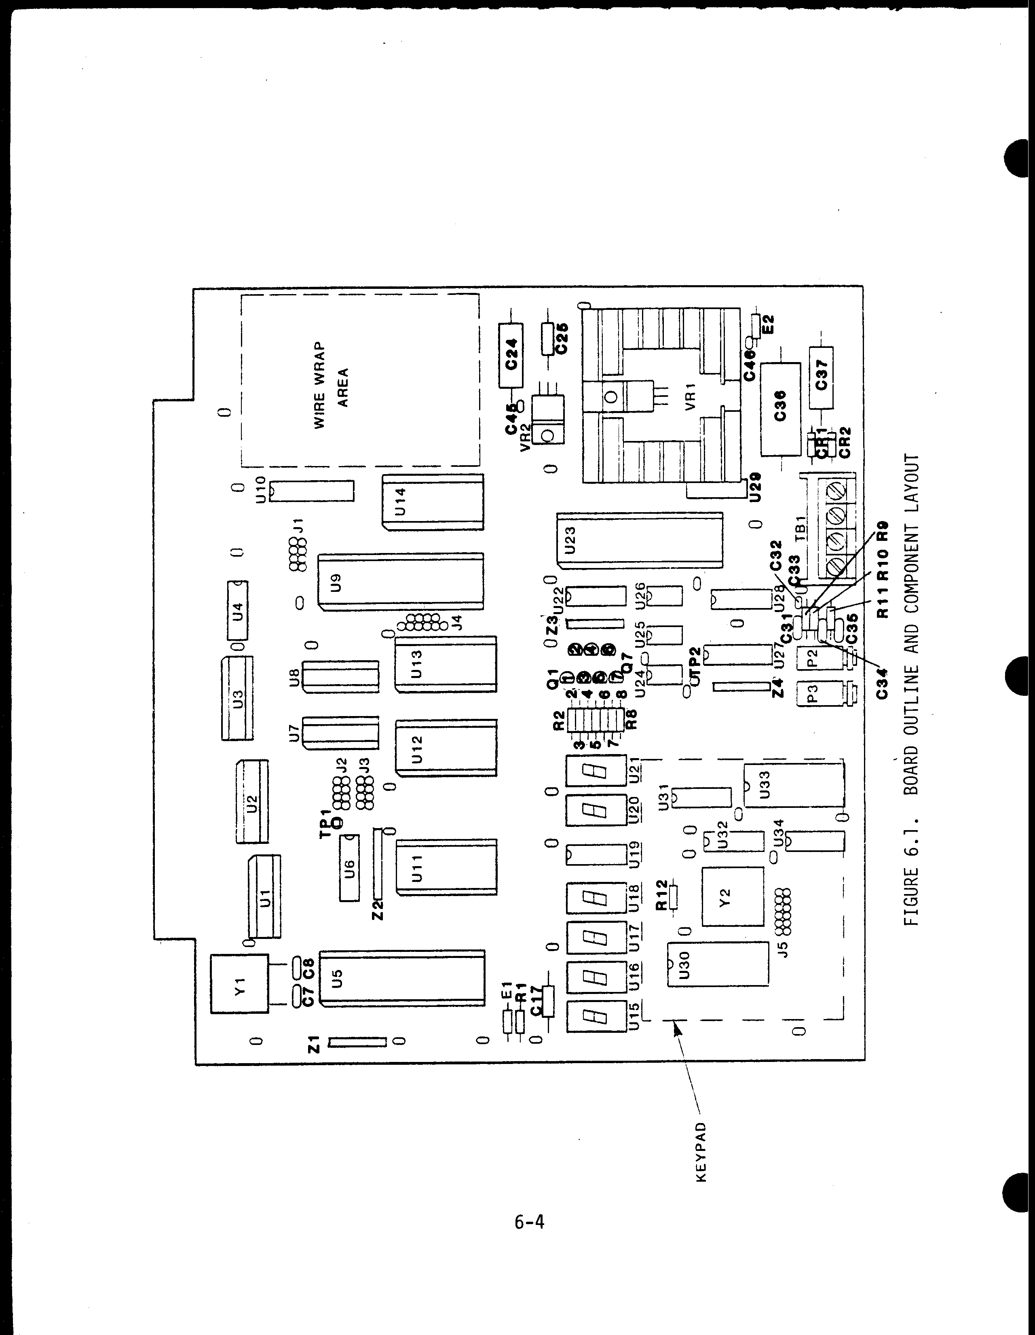
CHAPTER 7
SOFTWARE LISTING AND DESCRIPTIONS
7.1 General
This chapter consists of the subroutine descriptions, the D5BUG software
listing, and other useful information for the MEK6802D5.
7.2 Subroutine Descriptions
7.2.1 RESET ($F000)
Routine: Hardware Reset (cold start)
Descriptpn: Sets interrupt mask
Clears all RAM from $E400-E47F
Initializes system PIA
Establishes default user stack pointer ($E418)
Passes control to PROMPT routine
7.2.2 PROMPT ($F024)
Routine: Software Reset (warm start)
Description: Initializes system stack pointer ($E47E)
Sets-up software flags:
ROLPAS = 1
UPROG = 0
ROIFLG = 0
KYFLG = 0
FNCFL = 0
Clears 7 -Seg displays
Displays prompt symbol (-)
Establishes FUNSEL as active main program
7.2.3 GET ($F04E)
Routine: Subroutine to read, decode, and debounce a keypad
switch.
Effects: All registers are altered by this routine. The A-
register has the key code in it on return.
RAM location KYFLG will have $01 in it on return
and the code of the key that was depressed will be
in location KEY.
7-1

7.2.3 GET (cont'd)

Routines Called: DLY25
Stack Requirement: 4 bytes.
Description: The keys of the keypad are electrically arranged in-
to 6 rows and 4 columns. The "RS" (reset) key is
not part of this row/column arrangement. GET is
called when a key is depressed and the return does
not take place until about 25 milliseconds after the
key is released. While the key is closed, GET
searches the matrix to find the key's row then its
column. The Row/Column information is used to ad-
dress a look-up table from which a key code value
is fetched.
This code is stored to the RAM location KEY and is
also in the A-register when GET returns. A RAM
location called KYFLG is set to $01 to indicate
that a key was entered, when another routine re-
cognizes this flag, it should read the KEY code
and clear KYFLG, to acknowledge that the key was
seen.
Normally the GET routine is serviced through an
NMI which results when any key is closed but the
interrupt output of the KPD PIA could be disabled
allowing GET to work on a polled basis. Polling
means that periodically the PIA's control register
is read ("Polled") to see if a key was depressed
since the last time the program looked.

Calling Routines: NMINT

7-2
Key Code Summary
KEY | ROW | COL | "CODE”
0 | 0 | 0 | 0
F | 0 | 1 | 0F
E | 0 | 2 | 0E
D | 0 | 3 | 0D
1 | 1 | 0 | 1
2 | 1 | 1 | 2
3 | 1 | 2 | 3
C | 1 | 3 | 0C
4 | 2 | 0 | 4
5 | 2 | 1 | 5
6 | 2 | 2 | 6
B | 2 | 3 | 0B
7 | 3 | 0 | 7
8 | 3 | 1 | 8
9 | 3 | 2 | 9
A | 3 | 3 | 0A
FS | 4 | 0 | 84
FC | 4 | 1 | 85
P/L | 4 | 2 | 86
T/B | 4 | 3 | 87
MD | 5 | 0 | 80
EX | 5 | 1 | 81
RD | 5 | 2 | 82
GO | 5 | 3 | 83

Function Keys
KEY | "CODE”
MD | 80
EX | 81
RD | 82
GO | 83
FS | 84
FC | 85
P/L | 86
T/B | 87

NOTE: Function codes have MSB set to allow testing neg cond code

FIGURE 7.1. KEY CODE AND FUNCTION SUMMARY

7-3
7.2.4 PUT ($F0BB)

Routine: Utility program to display information on the 7-seg-
ment displays and call the active main program as a
subroutine once each millisecond.

Effects: The A, B, and X-registers are altered by PUT.

Routines Called: DLY1, routine specified by MNPTR.

Stack Requirement: 1 in addition to main program requirement (Minimum-
3 bytes total).

Description: The PUT routine is the heart of the operating system
because the displays must be continuously scanned.
Anode information for the desired display is presen-
ted to the parallel anode lines and the appropriate
cathode is driven turning on the proper segments. A
given digit is turned on for about one millisecond
then the cathode is disabled, the anode information
changed to that of the next digit, and the next
cathode is enabled.

During the short period between digits a subroutine
whose address is stored at RAM location MNPTR is ex-
ecuted. Upon RESET or PROMPT, MNPTR is set to the
address of the function select routine (FUNSEL).
When FUNSEL wishes to pass control to some other
routine, it stores the address of that routine at
MNPTR which ‘activates’ the new routine (and de-act-
ivates FUNSEL).

Another way of putting this is to say that the dis-
play routine calls ‘some program’ once per milli-
second and ‘some program’ is the program whose ad-
dress is stored at RAM location MNPTR.

The PUT routine obtains the segment information from
a 6-byte buffer called DISBUF, which contains 7-
segment data for the displays with the first byte
corresponding to the leftmost display. In addition
the B-register keeps track of which digit is to be
enabled with the third-from-the-left bit correspond-
ing to the leftmost display and the LSB correspond-
ing to the rightmost display.

NOTICE: The anode interface drivers are ground
true so the PUT routine inverts the data in DISBUF
before it is stored to the hardware so that the
data in DISBUF will be high true.

7-4
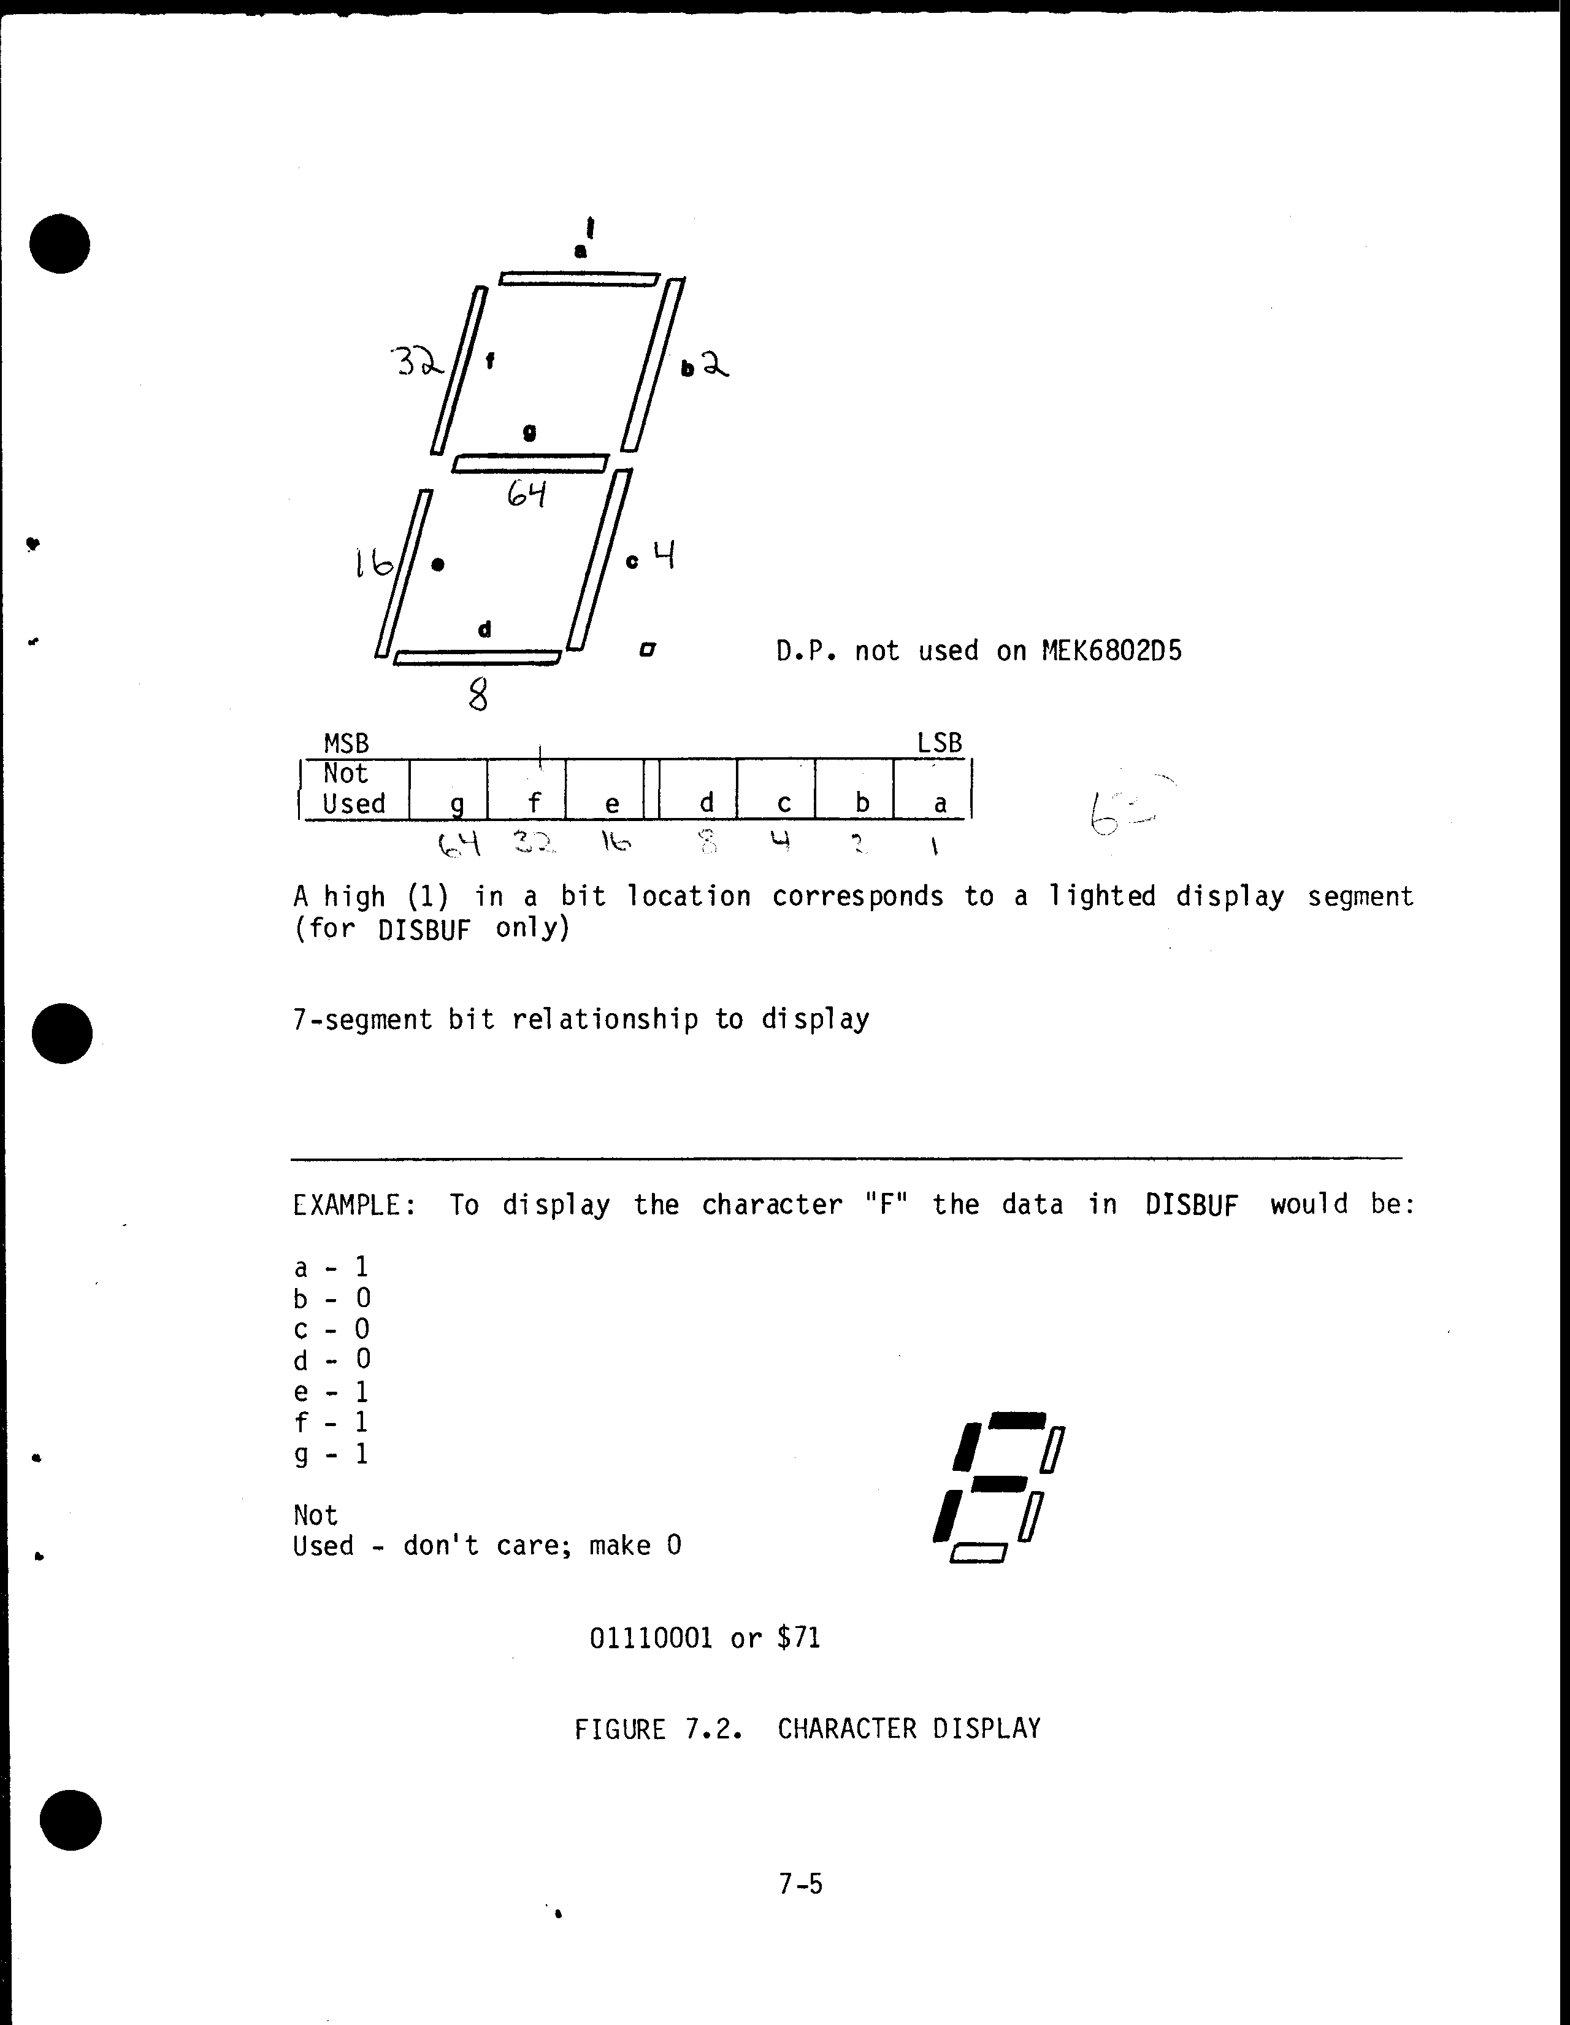
7.2.5 DYSCOD ($F120)
Routine: Convert hexadecimal data from HEXBUF into 7-segment
codes and store in DISBUF.
Effects: The contents of the A, B, and X-registers are saved
and restored prior to returning from DYSCOD.
On return the RAM locations DISBUF through DISBUF+5
contain the 7-segment codes for the hexadecimal
information in HEXBUF through HEXBUF+2.
Routines Called: ADDAX
Stack Requirement: 9 bytes.
Description: The six nibbles of hexadecimal information from
HEXBUF through HEXBUF+2 are each converted to a byte
of 7-segment anode information which is stored in the
six byte display buffer (DISBUF). The most signifi-
cant 4 bits of location HEXBUF correspond to the
location DISBUF and the least significant 4 bits
of HEXBUF+2 correspond to the location DISBUF+5.
The resulting 7-segment information is displayed on
the D5's six LED displays by the PUT routine. The
first byte of DISBUF corresponds to the leftmost
display and the sixth byte (DISBUF+5) corresponds
to the rightmost display.
7.2.6 DLY25, DLY1, DLYX ($F169) ($F171) ($F179)
Routine: These routines cause delays of 25 milliseconds, one
(1) millisecond, or a variable delay based on the
value in the X-register.
Effects: The contents of the X-register are saved and restor-
ed prior to returning from the routines. The A and
B-registers are not altered by the delay routines.
Stack Requirement: 2 bytes.
Description: Calling DLY25 or DLY1 will cause an execution time
delay of about 25 milliseconds or 1 millisecond re-
spectively. Calling DLYX will cause a delay based
on the value in the X-register according to the
following formula:
[(X-1) (8 cyc) (1.11763 us/cyc)] + (27.94 us)

7.2.6 DLY25, DLY1, DLYX (cont'd)
A minimum delay of 27.94 us results from an X-
register value of 1 ($0001) and a maximum delay of
0.5842 seconds results from an X-register value of
0 ($0000 - 1 = $FFFF = 65,535).
7.2.7 ADDAX ($F183)
Routine: Add A-register to X-register.
Effects: A and X-registers altered by ADDAX.
Stack Requirement: 2 bytes.
Description: The value in the A-register is added to the value
in the X-register and the result is returned in
the X-register.
7.2.8 CLRDS ($F195)
Routine: Clear LED display digits per a mask in the A-register.
Effects: The A-register is altered by CLRDS.
The contents of the X-register are saved and re-
stored prior to returning from CLRDS.
Stack Requirement: 2 bytes.

Description: Each of the low order six bits of the A-register cor-
respond to one of the D5's LED displays with the LSB
of the A-register corresponding to the rightmost dis-
play. For each bit that is a logic 1, the correspon-
ding display buffer location will be cleared result-
ing in that display going dark.

Example: 0011 1100 ($3C) would clear the first four LED dis-
plays.
7.2.9 ROLL2 ($F1AA)
Routine: Numeric entry routine for 2-digit (1-byte) values.

Requirements: Least significant 4-bits of A-register contain the
new hexadecimal digit and the most significant 4-
bits must be cleared.

7-7
7.2.9 ROLL2 (cont’d)
ROLPAS flag (when set) indicates “first pass” which
results in the location being cleared prior to rol-
ling the new digit in from right.
Effects: A-register altered by ROLL2, X-register contents
saved and restored prior to return from ROLL2.
Stack Requirement: 2 bytes.
Description: The address of the location to be operated on by
ROLL2 is specified in HEXBUF and HEXBUF+1. A new hex
digit is passed to ROLL2 in the least significant
4-bits of the A-register. This new digit is shifted
in from the right so that the digit which was in the
least significant 4-bits of the location is now in
the most significant 4-bits. The digit which was in
the most significant 4-bits is lost.
If the flag ROLPAS was not equal to zero, then the
location is cleared before the new digit is rolled in.
ROLPAS is cleared to signal it is no longer the first
pass.
7.2.10 ROLL4 ($F1CC)
Routine: Numeric entry routine for 4-digit (2-byte) values.
Requirements: ROLPAS flag (when set) indicates “first pass” which
results in the locatins HEXBUF and HEXBUF+1 being
cleared prior to rolling the new digit in from the
right.
The least significant 4-bits of the A-register con-
tains the new digit and the most significant 4-bits
of the A-register must be cleared.
Effects: A-register is altered by ROLL4, B-register is
saved and restored prior to returning from ROLL4.
Stack Requirement: 3 bytes.
Description: The locations into which ROLL4 shifts the new digit
are HEXBUF and HEXBUF+1. The new digit is passed to
ROLL4 in the least significant 4-bits of the A-re-
gister. This new digit is shifted into the first two
bytes of HEXBUF such that the new digit ends up in
the least significant 4-bits of HEXBUF+1. What was
in the low 4-bits ends up in the high 4-bits of HEX-
BUF+1 and what was in the high 4-bits of HEXBUF+1
7-8

7.2.10 ROLL4 (cont’d)
…ends up in the low 4-bits of HEXBUF. What was in the low 4-bits of HEXBUF ends up in the high 4-bits of HEXBUF, and what was in the high 4-bits of HEXBUF is lost.
If the ROLPAS flag was not equal to zero then HEXBUF and HEXBUF+1 will be cleared prior to shifting in the new digit, and ROLPAS will be cleared to indicate no longer first pass.

7.2.11 RDKEY ($F1EF)
Routine: Read and acknowledge a keypad key.
Requirements: Normally RDKEY would be called because KYFLG was set indicating that a key had been depressed.
Effects:
- KEY value returned in A-register.
- KYFLG cleared to acknowledge that the key has been recognized.
Stack Requirement: 2 bytes.
Description: Load the key code from KEY into the A-register and clear KYFLG to acknowledge that the key has been recognized.

7.2.12 TIN ($F533)
Routine: Read 1 byte of data from tape.
Effects: The A and B-register contents are altered by TIN.
On return the location BYTE ($E459) contains the character that was recovered from tape. The A-register also contains the recovered data.
Routines Called: FEDGE
Stack Requirement: 4 Bytes.
Description: TIN is used to read 1 Kansas City standard format character from cassette tape. The character format is:
a) Logic Ø Bit-Time = 4 cycles of 1200 Hz.

7.2.12 TIN (cont’d)
b) Logic 1 Bit-Time = 8 cycles of 2400 Hz.
c) Characters consist of:
i) 1 Logic 0 Bit-Time as a “Start” bit.
ii) 8 Data Bit-Times (LSB first).
iii) At least 2 logic 1 Bit-Times as “Stop” Bits.
Software timing techniques are used and an error tolerant algorithm considered to assure reliable data recovery. The TIN routine is in control from before a start bit until just after the eighth data bit in the serial stream.
During the stop bit-times the previous data character is processed by other software. At the 300 Baud data rate the stop bits take 13.3 milliseconds.
When reading successive data characters, the software which processes the previous byte read must finish in time to call TIN at least one full cycle before the next start bit-time. This will allow TIN to regain synchronization with the serial data stream.
The time required from the last cycle of the instruction that calls TIN to the first test for an edge is exactly 47 processor cycles or 52.5 microseconds.
The time from the end of the last cycle of the last data bit-time until the completion of TIN’s RTS instruction is 100 cycles or 111.2 microseconds.
Generally it will be easy to process the previous character in time to get back to TIN for the succeeding character.
7.2.13 PNCHB ($F608)
Routine: Format and send one byte of data to the tape interface.
Effects: The contents of the A and B-registers are altered during PNCHB.
Routines Called: BIT0, BIT1, INVRT.
Stack Requirement: 6 bytes.

7.2.13 PNCHB (cont’d)
Description:
Refer to the description of TIN for the format of tape characters.
Software timing techniques are used to create a serial stream of cycles of the proper duration to form Kansas City Standard audio signals.
When punching consecutive bytes of data it is vital to maintain timing control between successive bytes, not just within the character.
PNCHB consumes exactly 35 MPU cycles from the last MPU cycle of the calling instruction until the first start bit edge is sent. Timing is then automatically controlled by PNCHB while the character is being transmitted.
After transmitting the second last edge of the last stop bit PNCHB returns. The edge which marks the completion of the last stop bit cycle also marks the beginning of the succeeding start bit for the next character. It is supplied as the first edge transmitted by the next call to PNCHB.
The time allowed from the last cycle of PNCHB’s RTS until the next edge must be transmitted is exactly 159 MPU cycles.
159 minus the 35 for entry to PNCHB the next time leaves exactly 124 cycles which must be consumed by external software. For example, if it takes 50 cycles to set up for the next character, the remaining 74 (124-50) cycles must be consumed in dummy delays before calling PNCHB again.

7.2.14 PUNCH ($F630)
Routine:
Format and punch an entire file to the cassette.
Effects:
The A, B, and X-register contents are altered during PUNCH.
Routines Called:
PNCHB
Stack Requirement:
8 Bytes.
Description:
PUNCH is a time-tuned subroutine.

7.2.14 PUNCH (cont’d)
Before calling PUNCH store the beginning address of the data to be punched at RAM location BEGAD ($E460,1) and the ending address at ENDAD ($E462,3).
The file format is as follows:
a) 30 seconds of $FF characters as leader.
b) Block start character "S" ($53).
c) Begin address high byte.
d) Begin address low byte.
e) End address high byte.
f) End address low byte.
g) Data in binary form starting with data at Begin address to and including data at End address.
h) One byte checksum. Checksum is the two’s complement summation of all data bytes plus the begin and end address characters. When loading, the simple sum of all data in the file starting with the first byte of the begin address and including the checksum character should be zero.

7.2.15 LOAD ($F69C)
Routine: Load or verify a D5 format tape file to memory from cassette.
Effects: The A, B, and X-register contents are altered by LOAD.
Routines Called: TIN.
Stack Requirement: 6 bytes.
Description: The LOAD routine is used to read a tape data file into memory or verify a tape file against the contents of memory. If the least significant bit of the flag FNCFL ($E43E) is set, a load takes place, otherwise a verify is performed.
Normally if a checksum error is detected, an error message is displayed on the 7-segment LED’s.
This may be overridden by setting the MSB of FNCFL ($E43E) prior to calling LOAD. When the override feature is used, the Z condition code may be checked upon return from LOAD to determine if the load was acceptable. If Z is true the load was good.

GENERAL NOTE FOR CASSETTE ROUTINES
The cassette routines rely on critical execution time-tuning to work properly.
To use the individual routines outside the context of the D5BUG operating system, take care to abide by the timing requirements of the individual routines.
To assist in this effort, the number of processor cycles required by each instruction is presented as the first character(s) in the comment portion of each listing line for those routines.
7-13

7.3 Program Address Descriptions
TABLE 7.1. D5BUG USEFUL PROGRAM ADDRESSES
(Also Refer To Complete D5BUG Listing)
Name of Routine | ADDR in D5BUG | Description
RESET | $F000 | Cold Restart
PROMPT | $F024 | Warm Start
GET | $F04E | Routine to Read a Key (Uses NMI routine so a user would not normally use this routine directly.)
PUT | $F0BB | Display Data on 7-segment readouts and calls functioning subroutines.
DYSCOD | $F120 | Decode Hex to 7-segment.
DLY25 | $F169 | Delay 25 milliseconds.
DLY1 | $F171 | Delay 1 millisecond.
DLYX | $F179 | Delay based on X-Reg (about 1/2 second Max).
ADDAX | $F183 | Add A-Register to X-Register.
CLRDS | $F195 | Clear display digits per A-Register mask.
ROLL2 | $F1AA | Numeric entry routine for 2-digit values (one byte). Address being operated on specified in “HEXBUF”.
ROLL4 | $F1CC | Numeric entry routine for 4-digit values (2-Bytes).
RDKEY | $F1EF | Read and acknowledge key.
TIN* | $F533 | Read 1 byte from tape.
PNCHB* | $F630 | Format and punch a whole file.
LOAD* | $F69C | Load a whole file (if “FNCFL” ≠ 0). Verify a whole file (if “FNCFL” = 0).
* Tape routines have critically tuned execution times. Refer to detailed explanations.

Table 7.2 — Summary of most used D5BUG scratch RAM locations
Name | ADDR in D5BUG | Description
MNPTR | $E419,A. | Pointer to active sub-program.
KEY | $E41B | Entered key code from keypad.
KYFLG | $E41C | Flag to indicate a key is pending.
DISBUF | $E41D–E422 | (6) bytes correspond to (6) 7-segment displays. Contains 7-segment codes.
ROLPAS | $E423 | Flag to indicate first digit entry.
HEXBUF | $E42C,D,E | 3-byte buffer for hexadecimal information. Each byte corresponds to (2) 7-segment display digits.
USP | $E42F,30 | User stack pointer pseudo-register.
UCC | $E431 | User condition codes pseudo-register.
UB | $E432 | User B-register pseudo-register.
UA | $E433 | User A-register pseudo-register.
UX | $E434,5 | User X-register pseudo-register.
UPC | $E436,7 | User Program Counter pseudo-register.
UIRQV | $E43C,D | Points to user’s IRQ service routine.
FNCFL | $E43E | Flag to indicate special (or alternate) function.
FNCPNT | $E43F,40 | Points to ADDR of user’s special function table.
BYTE | $E459 | Data byte read from cassette or to be punched to cassette.
BEGAD | $E460,1 | Beginning Address (for punch).
ENDAD | $E462,3 | Ending Address (for punch).
* Tape routines have critically tuned execution times. Refer to detailed explanations.

Table 7.3 — Useful hardware address information
Item | Description
D5BUG ROM (U12) | $F000–F7FF, but also “mirrors” such that contents shown in the listing as addresses ($F400–F7FF) also appear at addresses ($FC00–FFFF). This mapping is controlled by jumper arrangement J2.
User ROM (U13) | ROM type controlled by J4 jumper arrangement (may be 1K×8 or 2K×8; single supply or triple supply; ROM or PROM). Mapping controlled by J3 jumper arrangement; may be mapped in any combination of the 1K address areas: $E800–EBFF; $EC00–EFFF; $F800–FBFF; $FC00–FFFF.
System Scratch RAM | Located at $E400–E47F. Further divided into (3) sections: $E400–E418 provided for user’s stack; $E419–E463 D5BUG scratch RAM; $E464–E47F D5BUG stack.
User RAM (in U5) | $0000–007F inside MC6802 (U5) available for user. Must be disabled by jumper E1 if expansion buffer (U3) is installed.
Optional RAM (U7, U8) | $E000–E3FF optional MCM2114 RAMs available for user.
System PIA | $E484–E487, broken down as: $E484 Data Port A; $E485 Control Reg A; $E486 Data Port B; $E487 Control Reg B. Also incomplete address decoding causes “mirroring”, making this PIA appear at addresses meeting: 1110 01XX 0XXX X0 XX (X = don’t care). Total number of “images” is 64, with first at $E484–E487 and last at $EF78–EF7B.

Table 7.3 (cont’d) — Useful hardware address information
Item | Description
User PIA | $E480–E483, broken down as: $E480 Data Port A; $E481 Control Reg A; $E482 Data Port B; $E483 Control Reg B. Also (as with the system PIA) incomplete address decoding causes “mirroring” at all addresses meeting: 1110 01XX 1XXX X1 XX. Total of 64 “images”, with the first at $E480–E483 and the last at $E7FC–E7FF.
ACIA (U33*) (optional — not used when keypad is present) | $E700, $E701, broken down as: $E700 Control/status register; $E701 Data register. Incomplete address decoding causes “mirroring” at all addresses meeting: 1110 0111 0XXX XXX X (2 regs in ACIA). Total of 64 “images”, with the first at $E700, $E701 and the last at $E77E, $E77F.
Off-board | $0000–$DFFF. This 56K address area is assumed to be external to the MEK6802D5 for expansion purposes. To use this address space, install U1, U2, and U3 buffers and E1 (jumper to disable RAM in MC6802, U5).

7.6 D5BUG Listing
The following is the D5BUG Program Listing. It consists of 35 pages.
Refer to paragraph 7.7 for a description of this listing.

RESET
0001
0002 NAM RESET
0003A F000 OPT CREF,LLEN=80
0004 ORG $F000
0005
0006 ************************************************************
0007 *
0008 * RESET - COLD START ROUTINE
0009 *
0010 ************************************************************
0009A F000 01 RESET NOP SET INTERRUPT MASK
0010A F001 0F SEI .
0011A F002 CE E3FF A LDX #$E3FF CLEAR RAM
0012A F005 08 CLRLOP INX .
0013A F006 6F 00 A CLR 0,X .
0014A F008 8C E487 A CPX #$E487 .
0015A F00B 26 F8 F005 A BNE CLRLOP .
0016A F00D CE E484 A LDX #$E484 INITIALIZE SYSTEM PIA
0017A F010 86 7F A LDAA #$7F .
0018A F012 A7 00 A STAA 0,X .
0019A F014 86 FF A LDAA #$FF .
0020A F016 A7 02 A STAA 2,X .
0021A F018 86 06 A LDAA #$06 .
0022A F01A A7 01 A STAA 1,X .
0023A F01C A7 03 A STAA 3,X .
0024A F01E CE E418 A LDX #$E418 DEFAULT USER STACK
0025A F021 FF E42F A STX USP .
0026
0027 ************************************************************
0028 *
0029 * PROMPT - ROUTINE TO SET UP PROMPT CONDITIONS
0030 *
0031 ************************************************************
0031A F024 8E E47E A PROMPT LDS #$STKTOP INIT SYSTEM STACK
0032A F027 86 01 A LDAA #1 SET FIRST PASS
0033A F029 B7 E423 A STAA ROLPAS .
0034A F02C 7F E43B A CLR UPROG INIT FLAGS
0035A F02F 7F E438 A CLR ROIFLG .
0036A F032 7F E41C A CLR KYFLG .
0037A F035 7F E43E A CLR FNCFL .
0038A F038 86 40 A LDAA #$40 DISPLAY PROMPT
0039A F03A B7 E41D A STAA DISBUF .
0040A F03D 86 1F A LDAA #%00011111 .
0041A F03F BD F195 A JSR CLRDS .
0042A F042 CE F0E5 A LDX #FUNSEL EXECUTE FUNCTION SELECT
0043A F045 FF E419 A STX MNPTR .
0044A F048 BD F7AE A JSR ENNMI ENABLE NMI
0045A F04B 7E F0BB A JMP PUT & GO
0001 NAM RESET
0002 OPT CREF,LLEN=80
0003A F000 ORG $F000
0004
0005 ****************************************************************
0006 *
0007 * RESET - COLD START ROUTINE
0008 *
0009 ****************************************************************
0009A F000 01 RESET NOP SET INTERRUPT MASK
0010A F001 0F SEI .
0011A F002 CE E3FF A LDX #$E3FF CLEAR RAM
0012A F005 08 CLRLOP INX .
0013A F006 6F 00 A CLR 0,X .
0014A F008 8C E487 A CPX #$E487 .
0015A F00B 26 F8 F005 A BNE CLRLOP .
0016A F00D CE E484 A LDX #$E484 INITIALIZE SYSTEM PIA
0017A F010 86 7F A LDAA #$7F .
0018A F012 A7 00 A STAA 0,X .
0019A F014 86 FF A LDAA #$FF .
0020A F016 A7 02 A STAA 2,X .
0021A F018 86 06 A LDAA #$06 .
0022A F01A A7 01 A STAA 1,X .
0023A F01C A7 03 A STAA 3,X .
0024A F01E CE E418 A LDX #$E418 DEFAULT USER STACK
0025A F021 FF E42F A STX USP .
0026 ****************************************************************
0027 *
0028 *
0029 * PROMPT - ROUTINE TO SET UP PROMPT CONDITIONS
0030 ****************************************************************
0031A F024 8E E47E A PROMPT LDS #STKTOP INIT SYSTEM STACK
0032A F027 86 01 A LDAA #1 SET FIRST PASS
0033A F029 B7 E423 A STAA ROLPAS .
0034A F02C 7F E43B A CLR UPROG INIT FLAGS
0035A F02F 7F E438 A CLR ROIFLG .
0036A F032 7F E41C A CLR KYFLG .
0037A F035 7F E43E A CLR FNCFL .
0038A F038 86 40 A LDAA #$40 DISPLAY PROMPT
0039A F03A B7 E41D A STAA DISBUF .
0040A F03D 86 1F A LDAA #%00011111 .
0041A F03F BD F195 A JSR CLRDS .
0042A F042 CE F0E5 A LDX #FUNSEL EXECUTE FUNCTION SELECT
0043A F045 FF E419 A STX MNPTR .
0044A F048 BD F7AE A JSR ENNMI ENABLE NMI
0045A F04B 7E F0BB A JMP PUT & GO
KPIO

0048 ***************************************************************
0049 *
0050 * GET - ROUTINE TO READ A KEY
0051 *
0052 ***************************************************************

0054A F04E CE E484 A GET LDX #PIA POINT AT PIA
0055A F051 86 FF A LDAA #$FF .
0056A F053 A7 00 A STAA KPCOL,X TO TURN OFF DISPLAYS
0057A F055 86 3F A LDAA #%00111111 COL 0, ALL ROWS
0058A F057 A7 02 A LPCOL STAA KPROW,X STORE INFO TO KEY MATRIX
0059A F059 6D 00 A TST KPCOL,X MSB IS MUX BIT
0060A F05B 2A 06 F063 BPL COLFND BIT-7 LOW MEANS COL FOUND
0061A F05D 8B 40 A ADDA #$40 INC COL BITS TO MUX
0062A F05F 24 F6 F057 BCC LPCOL CONTINUE FOR ALL COLS
0063A F061 20 EB F04E BRA GET KEY BOUNCED, START OVER
0064A F063 84 C0 A COLFND ANDA #%11000000 MASK TO SAVE ONLY COL
0065A F065 B7 E41B A STAA KEY WILL UPDATE LATER; JUST TEMP SAV
0066A F068 C6 20 A LDAB #%00100000 ROW 5
0067A F06A 17 LPROW TBA COPY ROW INFO TO A-REG
0068A F06B BA E41B A ORAA KEY COMBINE WITH COL INFO
0069A F06E A7 02 A STAA KPROW,X DRIVE KEY MATRIX
0070A F070 6D 00 A TST KPCOL,X MSB LOW = CLOSURE
0071A F072 2A 05 F079 BPL ROWFND
0072A F074 54 LSRB NEXT LOWER ROW BIT
0073A F075 26 F3 F06A BNE LPROW LOOP TILL ALL ROWS TRIED
0074A F077 20 D5 F04E BRA GET KEY BOUNCED; START OVER
0075A F079 4F ROWFND CLRA PREPARE TO FIND BINARY ROW #
0076A F07A 54 LPFND LSRB LOOP BUILDS BINARY ROW #
0077A F07B 25 03 F080 BCS DUNROW WHEN BIT FALLS OFF; A-REG HAS #
0078A F07D 4C INCA
0079A F07E 20 FA F07A BRA LPFND
0080A F080 79 E41B A DUNROW ROL KEY
0081A F083 49 A ROLA
0082A F084 79 E41B A ROL KEY
0083A F087 49 A ROLA A-REG IS 000RRRCC
0084 * A-REG NOW CONTAINS OFFSET FOR KEY LOOK-UP
0085A F088 6D 00 A CLOP TST KPCOL,X SEE IF KEY STILL DOWN
0086A F08A 2A FC F088 BPL CLOP WAIT TILL LET UP
0087A F08C BD F169 A JSR DLY25 DELAY TO DEBOUNCE
0088A F08F CE F0A3 A LDX #KYTBL POINT AT TOP OF TABLE
0089A F092 BD F183 A JSR ADDAX CALC ADDR OF KEY CODE
0090A F095 A6 00 A LDAA ,X GET KEY CODE
0091A F097 B7 E41B A STAA KEY SAVE KEY VALUE
0092A F09A C6 01 A LDAB #1
0093A F09C F7 E41C A STAB KYFLG INDICATE KEY PENDING
0094A F09F F6 E486 A LDAB PIAROW TO CLEAR NMI
0095A F0A2 39 DIDDLE RTS ** RETURN **
0096 *
0097 * THIS RTS IS USED AS A DO-NOTHING SUB
0098 * SO SYST CAN BE DISABLED EXCEPT DISPLAY
0099 *
0101 ************************************************************
0102 *
0103 * KYTBL - KEY VALUE TABLE
0104 *
0105 ************************************************************
0106A F0A3 00 A KYTBL FCB $00 '0' KEY
0107A F0A4 0F A FCB $0F 'F'
0108A F0A5 0E A FCB $0E 'E'
0109A F0A6 0D A FCB $0D 'D'
0110A F0A7 01 A FCB $01 '1'
0111A F0A8 02 A FCB $02 '2'
0112A F0A9 03 A FCB $03 '3'
0113A F0AA 0C A FCB $0C 'C'
0114A F0AB 04 A FCB $04 '4'
0115A F0AC 05 A FCB $05 '5'
0116A F0AD 06 A FCB $06 '6'
0117A F0AE 0B A FCB $0B 'B'
0118A F0AF 07 A FCB $07 '7'
0119A F0B0 08 A FCB $08 '8'
0120A F0B1 09 A FCB $09 '9'
0121A F0B2 0A A FCB $0A 'A'
0122A F0B3 84 A FCB $84 'FS' FUNCTION SET
0123A F0B4 85 A FCB $85 'FC' FUNCTION CLEAR
0124A F0B5 86 A FCB $86 'P/L' PUNCH/LOAD
0125A F0B6 87 A FCB $87 'T/B' TRACE/BREAK
0126A F0B7 80 A FCB $80 'MD' MEMORY DISPLAY
0127A F0B8 81 A FCB $81 'EX' ESCAPE
0128A F0B9 82 A FCB $82 'RD' REGISTER DISPLAY
0129A F0BA 83 A FCB $83 'GO' GO
[Page 7-21] PUT (KPIO listing)

0131 ************************************************************
0132 *
0133 * PUT - DISPLAYS DATA IN DISBUF & CALLS THE
0134 * FUNCTIONING SUBROUTINE
0135 *
0136 ************************************************************
0137A F0BB C6 20 A PUT LDAB #%00100000 INIT DIG ENABLE PATTERN
0138A F0BD CE E41A A LP1P LDX #DISBUF-3 POINT AT DISPLAY BUFFER
0139A F0C0 17 A TBA MAKE EXTRA COPY
0140A F0C1 08 LP2P INX POINT AT NXT DIGIT INFO
0141A F0C2 48 ASLA ADD 1 TO 'X' FOR EACH SHIFT
0142A F0C3 24 FC F0C1 BCC LP2P LOOP DEVELOPS DIGIT INFO ADDR
0143A F0C5 A6 00 A LDAA ,X GET SEG INFO
0144A F0C7 43 COMA ANODE DRIVERS ARE GND TRUE
0145A F0C8 B7 E484 A STAA ANOD STORE ANODE INFO TO PIA
0146A F0CB F7 E486 A STAB CATH ENABLE DIGIT CATHODE
0147A F0CE BD F171 A JSR DLY1 ON FOR 1 MILLISECOND
0148A F0D1 86 FF A LDAA #%11111111 1'S TURN OFF SEGS
0149A F0D3 B7 E484 A STAA ANOD TURN OFF ALL SEGS
0150A F0D6 B7 E486 A STAA CATH ENABLE ALL KPD ROWS
0151A F0D9 37 PSHB HAS ROTATING DIGIT ENABLE
0152A F0DA FE E419 A LDX MNPTR GET ADDRESS OF ACTIVE MAIN PROG
0153A F0DD AD 00 A JSR ,X EXECUTE IT
0154 ****
0155 **** SEE MANUAL
0156 ****
0157A F0DF 33 PULB RECOVER DIGIT ENABLE
0158A F0E0 54 LSRB NEXT DIGIT
0159A F0E1 26 DA F0BD BNE LP1P NOT THRU WHOLE CYCLE
0160A F0E3 20 D6 F0BB BRA PUT PAST LAST DIGIT
0161
FUNSEL
0164 ***************************************************************
0165 *
0166 * FUNSEL - ROUTINE TO SELECT A FUNCTION FROM A KEY INPUT
0167 *
0168 ***************************************************************

0169A FOE5 7D E41C A FUNSEL TST KYFLG KEY PENDING ?
0170A FOE8 26 01 FOEB BNE KEYNOW YES, TEST IT
0171A FOEA 39 RTS ** RETURN ** NO KEY PENDING
0172 *

0173A FOEB BD F1EF A KEYNOW JSR RDKEY GET & ACKNOWLEDGE KEY
0174A FOEE 2B 15 F105 BMI FUNKY IF FUNCTION KEY
0175A F0F0 7D E43E A TST FNCFL .
0176A F0F3 26 0B F100 BNE UFNK .
0177A F0F5 BD F1CC A JSR ROLL4 * ENTRY SO ROLL IT IN
0178A F0F8 BD F120 A JSR DYSCOD CONVERT TO 7-SEG
0179A F0FB 86 03 A LDAA #%00000011
0180A F0FD 7E F195 A JMP CLRDs BLANK LAST 2 DIGITS
0181 *

0182A F100 FE E43F A UFNK LDX FNCPNT POINT AT USER FUNCTION TABLE
0183A F103 20 03 F108 BRA HASH .
0184 *

0185A F105 CE F110 A FUNKY LDX #SYSFNC POINT AT SYSTEM FUNCTION TBL
0186A F108 48 HASH ASLA 2 BYTES PER ENTRY
0187A F109 BD F183 A JSR ADDAX DEVELOP POINTER
0188A F10C EE 00 A LDX ,X GET JMP ADDR
0189A F10E 6E 00 A JMP ,X ** GO THERE **
0190 *
0191 *

0192A F110 F1F6 A SYSFNC FDB MEMBEG 'MD'
0193A F112 F024 A FDB PROMPT 'EX'
0194A F114 F2CA A FDB REGBEG 'RD'
0195A F116 F6F3 A FDB GO 'GO'
0196A F118 F4C5 A FDB FSET 'FS'
0197A F11A F4D1 A FDB FCLR 'FC'
0198A F11C F4D7 A FDB TAPBEG 'P/L'
0199A F11E F388 A FDB BRKBEG 'T/B'
0200 *
0201
MISC
0204 ************************************************************
0205 *
0206 * MISC - MISC ROUTINES
0207 *
0208 ************************************************************
0209 * DECODE HEX TO 7-SEGMENT
0210 *
0211A F120 36 DYSCOD PSHA SAVE REGS
0212A F121 37 PSHB .
0213A F122 FF E426 A STX XSAV1 .
0214A F125 CE E42C A LDX #HEXBUF POINT AT HEX INFO
0215A F128 A6 00 A LP01 LDAA ,X GET HEX BYTE
0216A F12A 16 TAB MAKE EXTRA COPY
0217A F12B 54 LSRB RIGHT JUSTIFY HIGH NIBBLE
0218A F12C 54 LSRB .
0219A F12D 54 LSRB .
0220A F12E 54 LSRB . HIGH ORDER DIGIT IN B-REG
0221A F12F 84 0F A ANDA #$0F LOW ORDER DIGIT IN A-REG
0222A F131 37 PSHB SAVE ON STACK
0223A F132 36 PSHA .
0224A F133 08 INX NEXT HEX BYTE
0225A F134 8C E42F A CPX #HEXBUF+3 DONE ?
0226A F137 26 EF F128 BNE LP01 LOOP 3 TIMES
0227A F139 CE E422 A LDX #DISBUF+5 LAST DISPLAY BUFFER DIGIT
0228A F13C C6 05 A LDAB #5 LOOP INDEX
0229A F13E FF E428 A LP02 STX XTMP1 SAVE TEMPORARILY
0230A F141 CE F159 A LDX #DYSTBL POINT AT LOOK-UP TABLE
0231A F144 32 PULA GET A HEX DIGIT TO CONVERT
0232A F145 BD F183 A JSR ADDAX POINT AT 7-SEG EQUIV
0233A F148 A6 00 A LDAA ,X GET IT
0234A F14A FE E428 A LDX XTMP1 RECOVER POINTER TO DISP BUFFER
0235A F14D A7 00 A STAA ,X STORE CONVERTED DIG
0236A F14F 09 DEX NEXT DISPLAY POS
0237A F150 5A DECB LOOP INDEX
0238A F151 2A EB F13E BPL LP02 CONTINUE FOR 6 DIGITS
0239A F153 FE E426 A LDX XSAV1 RECOVER ENTRY STATUS
0240A F156 33 PULB
0241A F157 32 PULA
0242A F158 39 RTS ** RETURN **
0243 *
0244 *
0245A F159 3F A DYSTBL FCB %00111111 '0'
0246A F15A 06 A FCB %00000110 '1'
0247A F15B 5B A FCB %01011011 '2'
0248A F15C 4F A FCB %01001111 '3'
0249A F15D 66 A FCB %01100110 '4'
0250A F15E 6D A FCB %01101101 '5'
0251A F15F 7D A FCB %01111101 '6'
0252A F160 07 A FCB %00000111 '7'
0253A F161 7F A FCB %01111111 '8'
0254A F162 67 A FCB %01100111 '9'
0255A F163 77 A FCB %01110111 'A'
0256A F164 7C A FCB %01111100 'B'
0257A F165 39 A FCB %00111001 'C'
0258A F166 5E A FCB %01011110 'D'
0259A F167 79 A FCB %01111001 'E'
0260A F168 71 A FCB %01110001 'F'
0262 *
0263 * DELAY SUBS
0264 *
0265A F169 FF E424 A DLY25 STX XSAVD SAVE X ENTRY VALUE
0266A F16C CE 0AEA A LDX #2794 25 MS ENTRY POINT
0267A F16F 20 0B F17C BRA DLYLP
0268A F171 FF E424 A DLY1 STX XSAVD SAVE ENTRY VAL
0269A F174 CE 006D A LDX #109 1 MS COUNT
0270A F177 20 03 F17C BRA DLYLP
0271A F179 FF E424 A DLYX STX XSAVD REQUIRED FOR SIMILARITY TO DLY1/25
0272A F17C 09 A DLYLP DEX
0273A F17D 26 FD F17C BNE DLYLP LOOP TILL X=0
0274A F17F FE E424 A LDX XSAVD RECOVER ENTRY VALUE
0275A F182 39 RTS ** RETURN **
0276 *
0277 * SUBROUTINE TO ADD X=X+A
0278 *
0279A F183 FF E424 A ADDAX STX XSAVD TO ALLOW CALCS
0280A F186 BB E425 A ADDA XSAVD+1 ADD LOW BYTES
0281A F189 B7 E425 A STAA XSAVD+1 UPDATE
0282A F18C 24 03 F191 BCC ARND IF NO CARRY; YOU'RE DONE
0283A F18E 7C E424 A INC XSAVD ADD CARRY TO HIGH BYTE
0284A F191 FE E424 A ARND LDX XSAVD RESULT TO X-REG
0285A F194 39 RTS ** RETURN **
0286
0287 *
0288 * CLEAR DISPLAY PER A-REG
0289 *
0289A F195 FF E426 A CLRDS STX XSAV1 SAVE ENTRY VALUE
0290A F198 CE E422 A LDX #DISBUF+5 RIGHTMOST DIGIT
0291A F19B 44 A CLRLP LSRA
0292A F19C 24 02 F1 A0 BCC ARNCLR IF BIT IN A-REG NOT SET
0293A F19E 6F 00 A CLR ,X
0294A F1A0 09 A ARNCLR DEX NEXT DISPLAY
0295A F1A1 8C E41C A CPX #DISBUF-1 DONE ?
0296A F1A4 26 F5 F19B BNE CLRLP CONTINUE 6 TIMES
0297A F1A6 FE E426 A LDX XSAV1 RECOVER ENTRY VALUE
0298A F1A9 39 RTS ** RETURN **
0299 *
0300A F1AA FF E426 A ROLL2 STX XSAV1 SAVE ENTRY VALUE
0301A F1AD FE E42C A LDX HEXBUF ADDR TO ROLL
0302A F1B0 7D E423 A TST ROLPAS FIRST PASS ?
0303A F1B3 27 07 F1BC BEQ ARNCL2
0304A F1B5 7F E423 A CLR ROLPAS THIS WAS PASS 1
0305A F1B8 6F 00 A CLR ,X CLEAR LOC ON FIRST PASS
0306A F1BA 20 08 F1C4 BRA R2OUT
0307A F1BC 68 00 A ARNCL2 ASL ,X
0308A F1BE 68 00 A ASL ,X
0309A F1C0 68 00 A ASL ,X
0310A F1C2 68 00 A ASL ,X SHIFT ROLL BYTE 4 PLACES
0311A F1C4 AA 00 A R2OUT ORAA ,X COMBINE NEW DATA
0312A F1C6 A7 00 A STAA ,X UPDATE LOC
0313A F1C8 FE E426 A LDX XSAV1 RECOVER ENTRY VAL
0314A F1CB 39 RTS ** RETURN **
=====================
p. 7-25 ROLL4 / RDKEY
=====================
0316 *
0317 * ROLL 4 HEX INTO HEXBUF
0318 *
0319A F1CC 37 ROLL4 PSHB SAVE ENTRY VALUES
0320A F1CD 7D E423 A TST ROLPAS PASS 1 ?
0321A F1D0 27 0B F1DD A BEQ ARNCL4 NO,CONTINUE
0322A F1D2 7F E423 A CLR ROLPAS YES,CLEAR FIRST PASS FLAG &
0323A F1D5 7F E42C A CLR HEXBUF CLR FIRST 4 DIGITS ON FIRST PASS
0324A F1D8 B7 E42D A STAA HEXBUF+1 THEN PUT NEW DATA IN 4TH
0325A F1DB 20 10 F1ED A BRA R4OUT
0326A F1DD 48 ARNCL4 ASLA LEFT JUSTIFY NEW DIGIT
0327A F1DE 48 ASLA .
0328A F1DF 48 ASLA .
0329A F1E0 48 ASLA .
0330A F1E1 C6 03 A LDAB #3 LOOP INDEX
0331A F1E3 49 RO4LP ROLA ROLLA INTO HEXBUF
0332A F1E4 79 E42D A ROL HEXBUF+1 .
0333A F1E7 79 E42C A ROL HEXBUF .
0334A F1EA 5A DECB .
0335A F1EB 2A F6 F1E3 BPL RO4LP .
0336A F1ED 33 R4OUT PULB RECOVER B-REG
0337A F1EE 39 RTS ** RETURN **
0338 *
0339A F1EF 7F E41C A RDKEY CLR KYFLG READ & ACKNOWLEDGE KEY
0340A F1F2 B6 E41B A LDAA KEY
0341A F1F5 39 RTS
MEMCH

0344 ************************************************************
0345 * *
0346 * MEMCH - MEMORY CHANGE/DISPLAY/OFFSET ROUTINE *
0347 * *
0348 ************************************************************
0349A F1F6 CE F205 A MEMBEG LDX #MEMCH
0350A F1F9 FF E419 A STX MNPTR INIT MAIN POINTER
0351A F1FC 7F E43E A CLR FNCFL SET FUNCTION FLAG TO ZERO
0352A F1FF FE E42C A LDX HEXBUF POINT AT ADDR TO DISPLAY
0353A F202 7E F2BA A JMP NEWMEM EXIT TO UPDATE DISPLAY
0354 *
0355A F205 7D E41C A MEMCH TST KYFLG SEE IF ANY KEY PENDING
0356A F208 26 01 F20B BNE MEMNOW .
0357A F20A 39 RTS ** RETURN **
0358 *
0359A F20B BD F1EF A MEMNOW JSR RDKEY GET & ACKNOWLEDGE KEY
0360A F20E FE E42C A LDX HEXBUF SAVES STEPS LATER
0361A F211 F6 E43E A LDAB FNCFL SEE IF IN OFFSET MODE
0362A F214 27 77 F28D BEQ NORMAL (NOT OFFSET MODE)
0363A F216 2B 53 F26B BMI CALDUN IF OFFSET CALC FINISHED
0364A F218 4D TSTA CHECK KEY
0365A F219 2B 0D F228 BMI OFFUN IF FUNCTION KEY
0366A F21B BD F1CC A JSR ROLL4 ENTER NUMBER KEY
0367A F21E BD F120 A OFFOUT JSR DYSCOD CONVERT TO 7-SEG
0368A F221 CE 0077 A OFFEND LDX #$0077 "A"
0369A F224 FF E421 A STX DISBUF+4 STORE TO LAST DIGITS
0370A F227 39 OFFRET RTS ** RETURN **
0371 *
0372A F228 81 83 A OFFUN CMPA #$83 'GO'
0373A F22A 26 FB F227 BNE OFFRET IF NOT; EXIT
0374A F22C FE E42C A LDX HEXBUF GET DESTINATION OF BRANCH
0375A F22F 09 DEX ADJ INSTEAD OF ADJ'ING THE SOURCE
0376A F230 FF E42C A STX HEXBUF UPDATE
0377A F233 B6 E42D A LDAA HEXBUF+1 LOW BYTE OF DESTINATION
0378A F236 F6 E42C A LDAB HEXBUF HI BYTE
0379A F239 B0 E42B A SUBA MEMSAV+1 SUBTRACT LOW BYTES
0380A F23C F2 E42A A SBCB MEMSAV SUBTRACT W/ CARRY
0381A F23F 4D TSTA CHECK POLARITY OF LOW ORDER RESULT
0382A F240 2A 01 F243 BPL ARNINC IF LO POS DON'T INC HI
0383A F242 5C INCB IF LOW WAS NEG INC HI $FF - $00
0384A F243 5D ARNINC TSTB IF B NOW ZERO; OFFSET IS IN RANGE
0385A F244 26 11 F257 BNE BADOFF IF NOT; TOO FAR
0386A F246 B7 E42E A STAA HEXBUF+2 SAVE RESULT
0387A F249 BD F120 A JSR DYSCOD CONVERT TO 7-SEG
0388A F24C 86 3C A LDAA #%00111100 CLEAR FIRST 4 DISPLAYS
0389A F24E BD F195 A JSR CLRDS .
0390A F251 86 80 A LDAA #$80 .
0391A F253 B7 E43E A STAA FNCFL INDICATE CALC DONE; & OK
0392A F256 39 RTS ** RETURN **
0393 *
0394A F257 CE BAD0 A BADOFF LDX #$BAD0
0395A F25A FF E42C A STX HEXBUF
0396A F25D BD F120 A JSR DYSCOD WRITE "BAD" IN FIRST 3 DISPLAYS
0397A F260 86 07 A LDAA #%00000111 .
0398A F262 BD F195 A JSR CLRDS CLEAR UNUSED DIGITS
0399A F265 86 FF A LDAA #$FF .
0400A F267 B7 E43E A STAA FNCFL INDICATE OFFSET NOT VALID
0401A F26A 39 RTS ** RETURN **

